# Question #1

DRAG DROP -  
Your company intends to subscribe to an Azure support plan.  
The support plan must allow for new support requests to be opened.  
Which of the following are support plans that will allow this? Answer by dragging the correct option from the list to the answer area.  
Select and Place:  
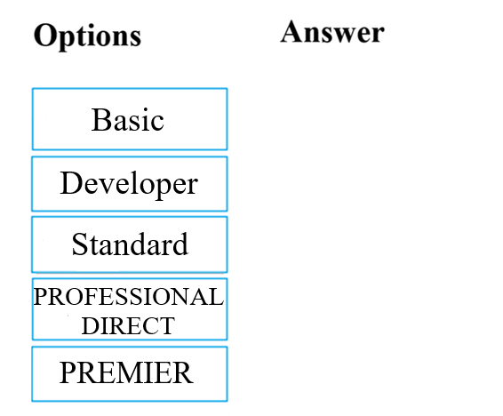

Developer, Standard, Professional Direct

# Question #2

Your company has datacenters in Los Angeles and New York. The company has a Microsoft Azure subscription.  
You are configuring the two datacenters as geo-clustered sites for site resiliency.  
You need to recommend an Azure storage redundancy option.  
You have the following data storage requirements:  
✑ Data must be stored on multiple nodes.  
✑ Data must be stored on nodes in separate geographic locations.  
✑ Data can be read from the secondary location as well as from the primary location  
Which of the following Azure stored redundancy options should you recommend?

* A. Geo-redundant storage
* B. Read-only geo-redundant storage
* C. Zone-redundant storage
* D. Locally redundant storage

B, there’s read-access geo-redundant storage. We only have this option to select.

# Question #3

Note: The question is included in a number of questions that depicts the identical set-up. However, every question has a distinctive result. Establish if the solution satisfies the requirements.  
Your companyג€™s Azure subscription includes a Basic support plan.  
They would like to request an assessment of an Azure environmentג€™s design from Microsoft. This is, however, not supported by the existing plan.  
You want to make sure that the company subscribes to a support plan that allows this functionality, while keeping expenses to a minimum.  
Solution: You recommend that the company subscribes to the Professional Direct support plan.  
Does the solution meet the goal?

* A. Yes
* B. No

B, developer support plan is enough.

# Question #4

Note: The question is included in a number of questions that depicts the identical set-up. However, every question has a distinctive result. Establish if the solution satisfies the requirements.  
You are tasked with deploying Azure virtual machines for your company.  
You need to make use of the appropriate cloud deployment solution.  
Solution: You should make use of Software as a Service (SaaS).  
Does the solution meet the goal?

* A. Yes
* B. No

B

# Question #5

Note: The question is included in a number of questions that depicts the identical set-up. However, every question has a distinctive result. Establish if the solution satisfies the requirements.  
You are tasked with deploying Azure virtual machines for your company.  
You need to make use of the appropriate cloud deployment solution.  
Solution: You should make use of Platform as a Service (PaaS).  
Does the solution meet the goal?

* A. Yes
* B. No

B

# Question #6

Note: The question is included in a number of questions that depicts the identical set-up. However, every question has a distinctive result. Establish if the solution satisfies the requirements.  
You are tasked with deploying Azure virtual machines for your company.  
You need to make use of the appropriate cloud deployment solution.  
Solution: You should make use of Infrastructure as a Service (IaaS).  
Does the solution meet the goal?

* A. Yes
* B. No

A

# Question #7

Your developers have created 10 web applications that must be host on Azure.  
You need to determine which Azure web tier plan to host the web apps. The web tier plan must meet the following requirements:  
✑ The web apps will use custom domains.  
✑ The web apps each require 10 GB of storage.  
✑ The web apps must each run in dedicated compute instances.  
✑ Load balancing between instances must be included.  
✑ Costs must be minimized.  
Which web tier plan should you use?

* A. Standard
* B. Basic
* C. Free
* D. Shared

A

# Question #8

Note: The question is included in a number of questions that depicts the identical set-up. However, every question has a distinctive result. Establish if the solution satisfies the requirements.  
You are planning to migrate a company to Azure. Each of the companyג€™s numerous divisions will have an administrator in place to manage the Azure resources used by their respective division.  
You want to make sure that the Azure deployment you employ allows for Azure to be segmented for the divisions, while keeping administrative effort to a minimum.  
Solution: You plan to make use of several Azure Active Directory (Azure AD) directories.  
Does the solution meet the goal?

* A. Yes
* B. No

B

# Question #9

Your developers have created a portal web app for users in the Miami branch office. The web app will be publicly accessible and used by the Miami users to retrieve customer and product information. The web app is currently running in an on-premises test environment.  
You plan to host the web app on Azure.  
You need to determine which Azure web tier plan to host the web app. The web tier plan must meet the following requirements:  
✑ The website will use the miami.weyland.com URL.  
✑ The website will be deployed to two instances.  
✑ SSL support must be included.  
✑ The website requires 12 GB of storage.  
✑ Costs must be minimized.  
Which web tier plan should you use?

* A. Standard
* B. Basic
* C. Free
* D. Shared

A

# Question #10

Note: The question is included in a number of questions that depicts the identical set-up. However, every question has a distinctive result. Establish if the solution satisfies the requirements.  
Your company is planning to migrate all their virtual machines to an Azure pay-as-you-go subscription. The virtual machines are currently hosted on the Hyper-V hosts in a data center.  
You are required make sure that the intended Azure solution uses the correct expenditure model.  
Solution: You should recommend the use of the elastic expenditure model.  
Does the solution meet the goal?

* A. Yes
* B. No

B

# Question #11

Note: The question is included in a number of questions that depicts the identical set-up. However, every question has a distinctive result. Establish if the solution satisfies the requirements.  
Your company is planning to migrate all their virtual machines to an Azure pay-as-you-go subscription. The virtual machines are currently hosted on the Hyper-V hosts in a data center.  
You are required make sure that the intended Azure solution uses the correct expenditure model.  
Solution: You should recommend the use of the scalable expenditure model.  
Does the solution meet the goal?

* A. Yes
* B. No

B

# Question #12

Note: The question is included in a number of questions that depicts the identical set-up. However, every question has a distinctive result. Establish if the solution satisfies the requirements.  
Your company is planning to migrate all their virtual machines to an Azure pay-as-you-go subscription. The virtual machines are currently hosted on the Hyper-V hosts in a data center.  
You are required make sure that the intended Azure solution uses the correct expenditure model.  
Solution: You should recommend the use of the operational expenditure model.  
Does the solution meet the goal?

* A. Yes
* B. No

A

# Question #13

Note: The question is included in a number of questions that depicts the identical set-up. However, every question has a distinctive result. Establish if the solution satisfies the requirements.  
You are required to deploy an Artificial Intelligence (AI) solution in Azure.  
You want to make sure that you are able to build, test, and deploy predictive analytics for the solution.  
Solution: You should make use of Azure Cosmos DB.  
Does the solution meet the goal?

* A. Yes
* B. No

**B**

# Question #14

Note: The question is included in a number of questions that depicts the identical set-up. However, every question has a distinctive result. Establish if the solution satisfies the requirements.  
Your companyג€™s Active Directory forest includes thousands of user accounts.  
You have been informed that all network resources will be migrated to Azure. Thereafter, the on-premises data center will be retired.  
You are required to employ a strategy that reduces the effect on users, once the planned migration has been completed.  
Solution: You plan to sync all the Active Directory user accounts to Azure Active Directory (Azure AD).  
Does the solution meet the goal?

* A. Yes
* B. No

**A**

# Question #15

Note: The question is included in a number of questions that depicts the identical set-up. However, every question has a distinctive result. Establish if the solution satisfies the requirements.  
You are required to deploy an Artificial Intelligence (AI) solution in Azure.  
You want to make sure that you are able to build, test, and deploy predictive analytics for the solution.  
Solution: You should make use of Azure Machine Learning Studio.  
Does the solution meet the goal?

* A. Yes
* B. No

**A**

# Question #16

Note: The question is included in a number of questions that depicts the identical set-up. However, every question has a distinctive result. Establish if the solution satisfies the requirements.  
Your companyג€™s infrastructure includes a number of business units that each need a large number of various Azure resources for everyday operation.  
The resources required by each business unit are identical.  
You are required to sanction a strategy to create Azure resources automatically.  
Solution: You recommend that the Azure API Management service be included in the strategy.  
Does the solution meet the goal?

* A. Yes
* B. No

**B**

# Question #17

Note: The question is included in a number of questions that depicts the identical set-up. However, every question has a distinctive result. Establish if the solution satisfies the requirements.  
Your companyג€™s infrastructure includes a number of business units that each need a large number of various Azure resources for everyday operation.  
The resources required by each business unit are identical.  
You are required to sanction a strategy to create Azure resources automatically.  
Solution: You recommend that management groups be included in the strategy.  
Does the solution meet the goal?

* A. Yes
* B. No

**B**

# Question #18

Note: The question is included in a number of questions that depicts the identical set-up. However, every question has a distinctive result. Establish if the solution satisfies the requirements.  
Your companyג€™s infrastructure includes a number of business units that each need a large number of various Azure resources for everyday operation.  
The resources required by each business unit are identical.  
You are required to sanction a strategy to create Azure resources automatically.  
Solution: You recommend that the Azure Resource Manager templates be included in the strategy.  
Does the solution meet the goal?

* A. Yes
* B. No

**A**

# Question #19

Note: The question is included in a number of questions that depicts the identical set-up. However, every question has a distinctive result. Establish if the solution satisfies the requirements.  
You are tasked with deploying a critical LOB application, which will be installed on a virtual machine, to Azure.  
You are informed that the application deployment strategy should allow for a guaranteed availability of 99.99 percent. You need to make sure that the strategy requires as little virtual machines and availability zones as possible.  
Solution: You include two virtual machines and one availability zone in your strategy.  
Does the solution meet the goal?

* A. Yes
* B. No

**B**

# Question #20

Note: The question is included in a number of questions that depicts the identical set-up. However, every question has a distinctive result. Establish if the solution satisfies the requirements.  
You are tasked with deploying a critical LOB application, which will be installed on a virtual machine, to Azure.  
You are informed that the application deployment strategy should allow for a guaranteed availability of 99.99 percent. You need to make sure that the strategy requires as little virtual machines and availability zones as possible.  
Solution: You include one virtual machine and two availability zones in your strategy.  
Does the solution meet the goal?

* A. Yes
* B. No

**B**

# Question #21

Note: The question is included in a number of questions that depicts the identical set-up. However, every question has a distinctive result. Establish if the solution satisfies the requirements.  
You are tasked with deploying a critical LOB application, which will be installed on a virtual machine, to Azure.  
You are informed that the application deployment strategy should allow for a guaranteed availability of 99.99 percent. You need to make sure that the strategy requires as little virtual machines and availability zones as possible.  
Solution: You include two virtual machines and two availability zones in your strategy.  
Does the solution meet the goal?

* A. Yes
* B. No

**A**

# Question #22

Note: The question is included in a number of questions that depicts the identical set-up. However, every question has a distinctive result. Establish if the solution satisfies the requirements.  
Your companyג€™s developers intend to deploy a large number of custom virtual machines on a weekly basis. They will also be removing these virtual machines during the same week it was deployed. Sixty percent of the virtual machines have Windows Server 2016 installed, while the other forty percent has Ubuntu Linux installed.  
You are required to make sure that the administrative effort, needed for this process, is reduced by employing a suitable Azure service.  
Solution: You recommend the use of Microsoft Managed Desktop.  
Does the solution meet the goal?

* A. Yes
* B. No

**B**

# Question #23

Note: The question is included in a number of questions that depicts the identical set-up. However, every question has a distinctive result. Establish if the solution satisfies the requirements.  
Your companyג€™s developers intend to deploy a large number of custom virtual machines on a weekly basis. They will also be removing these virtual machines during the same week it was deployed. Sixty percent of the virtual machines have Windows Server 2016 installed, while the other forty percent has Ubuntu Linux installed.  
You are required to make sure that the administrative effort, needed for this process, is reduced by employing a suitable Azure service.  
Solution: You recommend the use of Azure Reserved Virtual Machines (VM) Instances.  
Does the solution meet the goal?

* A. Yes
* B. No

**B**

# Question #24

Note: The question is included in a number of questions that depicts the identical set-up. However, every question has a distinctive result. Establish if the solution satisfies the requirements.  
Your companyג€™s developers intend to deploy a large number of custom virtual machines on a weekly basis. They will also be removing these virtual machines during the same week it was deployed. Sixty percent of the virtual machines have Windows Server 2016 installed, while the other forty percent has Ubuntu Linux installed.  
You are required to make sure that the administrative effort, needed for this process, is reduced by employing a suitable Azure service.  
Solution: You recommend the use of Azure DevTest Labs.  
Does the solution meet the goal?

* A. Yes
* B. No

**A**

# Question #25

Your company has virtual machines (VMs) hosted in Microsoft Azure. The VMs are located in a single Azure virtual network named VNet1.  
The company has users that work remotely. The remote workers require access to the VMs on VNet1.  
You need to provide access for the remote workers.  
What should you do?

* A. Configure a Site-to-Site (S2S) VPN.
* B. Configure a VNet-toVNet VPN.
* C. Configure a Point-to-Site (P2S) VPN.
* D. Configure DirectAccess on a Windows Server 2012 server VM.
* E. Configure a Multi-Site VPN

**C**

# Question #26

Note: The question is included in a number of questions that depicts the identical set-up. However, every question has a distinctive result. Establish if the solution satisfies the requirements.  
You have been informed by your superiors of the companyג€™s intentions to automate server deployment to Azure. There is, however, some concern that administrative credentials could be uncovered during this process.  
You are required to make sure that during the deployment, the administrative credentials are encrypted using a suitable Azure solution.  
Solution: You recommend the use of Azure Information Protection.  
Does the solution meet the goal?

* A. Yes
* B. No

**B**

# Question #27

Note: The question is included in a number of questions that depicts the identical set-up. However, every question has a distinctive result. Establish if the solution satisfies the requirements.  
You have been informed by your superiors of the companyג€™s intentions to automate server deployment to Azure. There is, however, some concern that administrative credentials could be uncovered during this process.  
You are required to make sure that during the deployment, the administrative credentials are encrypted using a suitable Azure solution.  
Solution: You recommend the use of Azure Multi-Factor Authentication (MFA).  
Does the solution meet the goal?

* A. Yes
* B. No

**B**

# Question #28

DRAG DROP -  
The company would like to develop a cloud solution by making use of Azure Government. Azure Government can only be used by certain types of clients to develop cloud solutions.  
Which of the following are the types of customers that can make use of Azure Government in this situation? Answer by dragging the correct option from the list to the answer area.  
Select and Place:  
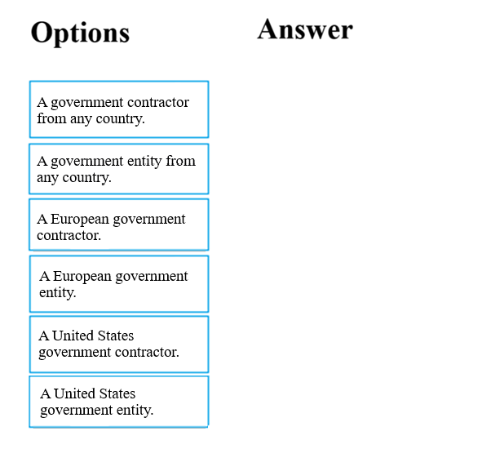

**A United Status government contractor, A United Status government entity.**

# Question #29

Note: The question is included in a number of questions that depicts the identical set-up. However, every question has a distinctive result. Establish if the solution satisfies the requirements.  
Your company has an Azure Active Directory (Azure AD) environment. Users occasionally connect to Azure AD via the Internet.  
You have been tasked with making sure that users who connect to Azure AD via the internet from an unidentified IP address, are automatically encouraged to change passwords.  
Solution: You configure the use of Azure AD Identity Protection.  
Does the solution meet the goal?

* A. Yes
* B. No

**A**

# Question #30

Note: The question is included in a number of questions that depicts the identical set-up. However, every question has a distinctive result. Establish if the solution satisfies the requirements.  
Your company has an Azure Active Directory (Azure AD) environment. Users occasionally connect to Azure AD via the Internet.  
You have been tasked with making sure that users who connect to Azure AD via the internet from an unidentified IP address, are automatically encouraged to change passwords.  
Solution: You configure the use of Azure AD Privileged Identity Management.  
Does the solution meet the goal?

* A. Yes
* B. No

**B**

# Question #31

Note: The question is included in a number of questions that depicts the identical set-up. However, every question has a distinctive result. Establish if the solution satisfies the requirements.  
You are planning a strategy to deploy numerous web servers and database servers to Azure.  
This strategy should allow for connection types between the web servers and database servers to be controlled.  
Solution: You include network security groups (NSGs) in your strategy.  
Does the solution meet the goal?

* A. Yes
* B. No

**A**

# Question #32

Note: The question is included in a number of questions that depicts the identical set-up. However, every question has a distinctive result. Establish if the solution satisfies the requirements.  
You are planning a strategy to deploy numerous web servers and database servers to Azure.  
This strategy should allow for connection types between the web servers and database servers to be controlled.  
Solution: You include a local network gateway in your strategy.  
Does the solution meet the goal?

* A. Yes
* B. No

**B**

# Question #33

Note: The question is included in a number of questions that depicts the identical set-up. However, every question has a distinctive result. Establish if the solution satisfies the requirements.  
Your companyג€™s Active Directory forest includes thousands of user accounts.  
You have been informed that all network resources will be migrated to Azure. Thereafter, the on-premises data center will be retired.  
You are required to employ a strategy that reduces the effect on users, once the planned migration has been completed.  
Solution: You plan to require Azure Multi-Factor Authentication (MFA).  
Does the solution meet the goal?

* A. Yes
* B. No

**A**

# Question #34

HOTSPOT -  
For each of the following statements, select Yes if the statement is true. Otherwise, select No.  
NOTE: Each correct selection is worth one point.Hot Area:  
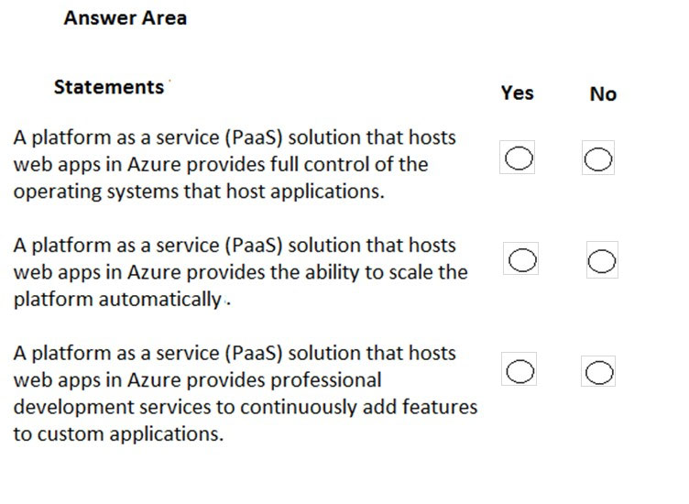

**No, Yes, Yes**

# Question #35

HOTSPOT -  
For each of the following statements, select Yes if the statement is true. Otherwise, select No.  
NOTE: Each correct selection is worth one point.  
Hot Area:  
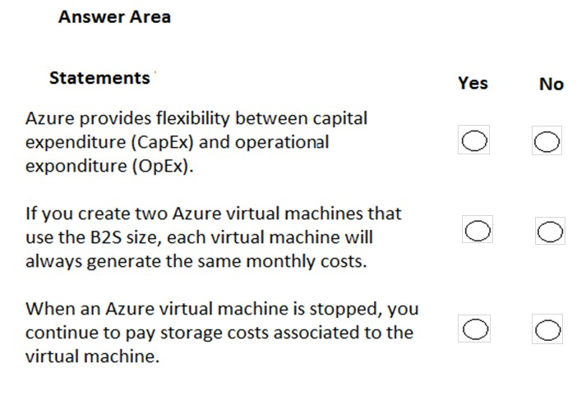

**Yes, No, Yes**

# Question #36

HOTSPOT -  
To complete the sentence, select the appropriate option in the answer area.  
Hot Area:  
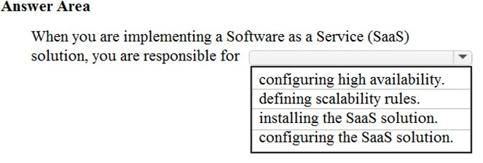

**Configurating the SaaS solution**

# Question #37

You have an on-premises network that contains several servers.  
You plan to migrate all the servers to Azure.  
You need to recommend a solution to ensure that some of the servers are available if a single Azure data center goes offline for an extended period.  
What should you include in the recommendation?

* A. fault tolerance
* B. elasticity
* C. scalability
* D. low latency

**A**

# Question #38

HOTSPOT -  
To complete the sentence, select the appropriate option in the answer area.  
Hot Area:  
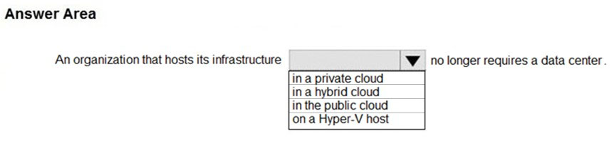

**In the public cloud**

# Question #39

What are two characteristics of the public cloud? Each correct answer presents a complete solution.  
NOTE: Each correct selection is worth one point.

* A. dedicated hardware
* B. unsecured connections
* C. limited storage
* D. metered pricing
* E. self-service management

**D,E**

# Question #40

HOTSPOT -  
To complete the sentence, select the appropriate option in the answer area.  
Hot Area:  
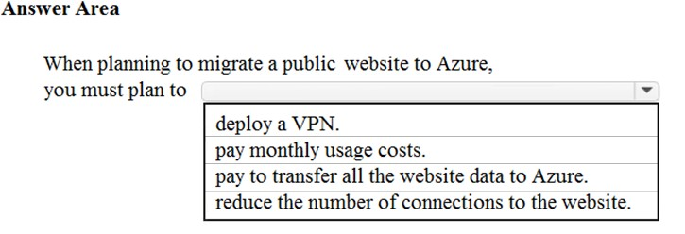

**Pay monthly usage costs**

# Question #41

Note: This question is part of a series of questions that present the same scenario. Each question in the series contains a unique solution that might meet the stated goals. Some question sets might have more than one correct solution, while others might not have a correct solution.  
After you answer a question in this section, you will NOT be able to return to it. As a result, these questions will not appear in the review screen.  
Your company plans to migrate all its data and resources to Azure.  
The companyג€™s migration plan states that only Platform as a Service (PaaS) solutions must be used in Azure.  
You need to deploy an Azure environment that meets the company migration plan.  
Solution: You create an Azure App Service and Azure SQL databases.  
Does this meet the goal?

* A. Yes
* B. No

**A**

# Question #42

Note: This question is part of a series of questions that present the same scenario. Each question in the series contains a unique solution that might meet the stated goals. Some question sets might have more than one correct solution, while others might not have a correct solution.  
After you answer a question in this section, you will NOT be able to return to it. As a result, these questions will not appear in the review screen.  
Your company plans to migrate all its data and resources to Azure.  
The companyג€™s migration plan states that only Platform as a Service (PaaS) solutions must be used in Azure.  
You need to deploy an Azure environment that meets the company migration plan.  
Solution: You create an Azure App Service and Azure virtual machines that have Microsoft SQL Server installed.  
Does this meet the goal?

* A. Yes
* B. No

**B**

# Question #43

Note: This question is part of a series of questions that present the same scenario. Each question in the series contains a unique solution that might meet the stated goals. Some question sets might have more than one correct solution, while others might not have a correct solution.  
After you answer a question in this section, you will NOT be able to return to it. As a result, these questions will not appear in the review screen.  
Your company plans to migrate all its data and resources to Azure.  
The companyג€™s migration plan states that only Platform as a Service (PaaS) solutions must be used in Azure.  
You need to deploy an Azure environment that meets the company migration plan.  
Solution: You create an Azure App Service and Azure Storage accounts.  
Does this meet the goal?

* A. Yes
* B. No

**A**

**B**

# Question #44

Your company hosts an accounting application named App1 that is used by all the customers of the company.  
App1 has low usage during the first three weeks of each month and very high usage during the last week of each month.  
Which benefit of Azure Cloud Services supports cost management for this type of usage pattern?

* A. high availability
* B. high latency
* C. elasticity
* D. load balancing

**C**

# Question #45

You plan to migrate a web application to Azure. The web application is accessed by external users.  
You need to recommend a cloud deployment solution to minimize the amount of administrative effort used to manage the web application.  
What should you include in the recommendation?

* A. Software as a Service (SaaS)
* B. Platform as a Service (PaaS)
* C. Infrastructure as a Service (IaaS)
* D. Database as a Service (DaaS)

**B**

# Question #46

HOTSPOT -  
Which cloud deployment solution is used for Azure virtual machines and Azure SQL databases? To answer, select the appropriate options in the answer area.  
NOTE: Each correct selection is worth one point.  
Hot Area:  
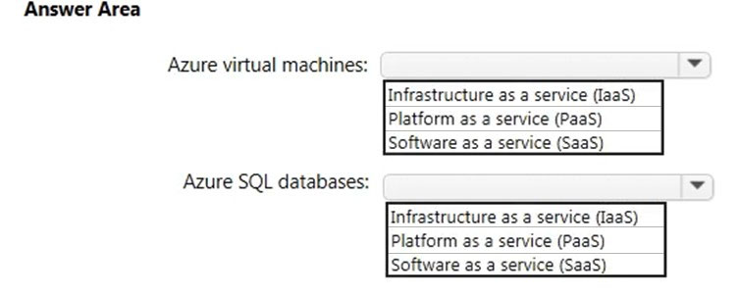

Infrastructure as a service (IaaS), Platform as a service (PaaS)

# Question #47

You have an on-premises network that contains 100 servers.  
You need to recommend a solution that provides additional resources to your users. The solution must minimize capital and operational expenditure costs.  
What should you include in the recommendation?

* A. a complete migration to the public cloud
* B. an additional data center
* C. a private cloud
* D. a hybrid cloud

D

# Question #48

HOTSPOT -  
For each of the following statements, select Yes if the statement is true. Otherwise, select No.  
NOTE: Each correct selection is worth one point.  
Hot Area:  
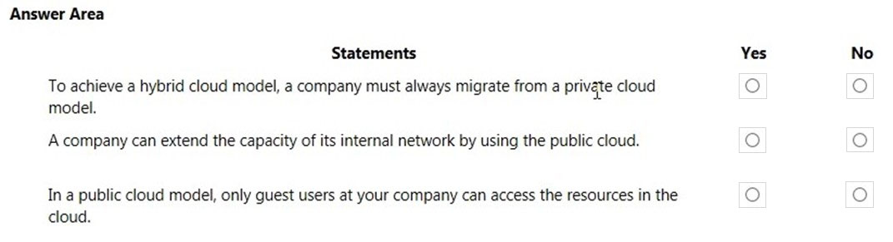

No, Yes, No

# Question #49

You plan to migrate several servers from an on-premises network to Azure.  
What is an advantage of using a public cloud service for the servers over an on-premises network?

* A. The public cloud is owned by the public, NOT a private corporation
* B. The public cloud is a crowd-sourcing solution that provides corporations with the ability to enhance the cloud
* C. All public cloud resources can be freely accessed by every member of the public
* D. The public cloud is a shared entity whereby multiple corporations each use a portion of the resources in the cloud

**D**

# Question #50

HOTSPOT -  
To complete the sentence, select the appropriate option in the answer area.  
Hot Area:  
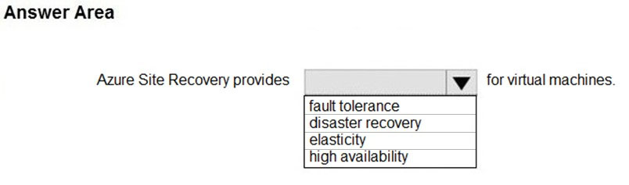

**Disaster recovery**

# Question #51

In which type of cloud model are all the hardware resources owned by a third-party and shared between multiple tenants?

* A. private
* B. hybrid
* C. public

**C**

# Question #52

HOTSPOT -  
To complete the sentence, select the appropriate option in the answer area.  
Hot Area:  
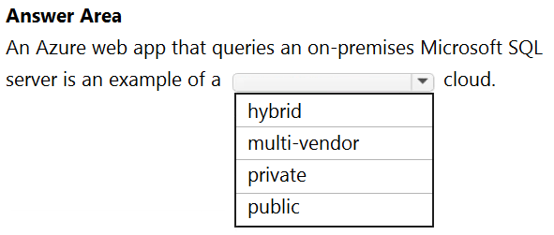

Hybrid

# Question #53

You have 1,000 virtual machines hosted on the Hyper-V hosts in a data center.  
You plan to migrate all the virtual machines to an Azure pay-as-you-go subscription.  
You need to identify which expenditure model to use for the planned Azure solution.  
Which expenditure model should you identify?

* A. operational
* B. elastic
* C. capital
* D. scalable

**A**

# Question #54

DRAG DROP -  
Match the Azure services benefits to the correct descriptions.  
Instructions: To answer, drag the appropriate benefit from the column on the left to its description on the right. Each benefit may be used once, more than once, or not at all.  
NOTE: Each correct match is worth one point.  
Select and Place:  
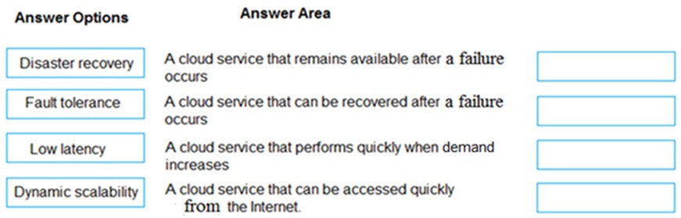

**Fault tolerance, disaster recovery, dynamic scalability, low latency**

# Question #55

HOTSPOT -  
For each of the following statements, select Yes if the statement is true. Otherwise, select No.  
NOTE: Each correct selection is worth one point.  
Hot Area:  
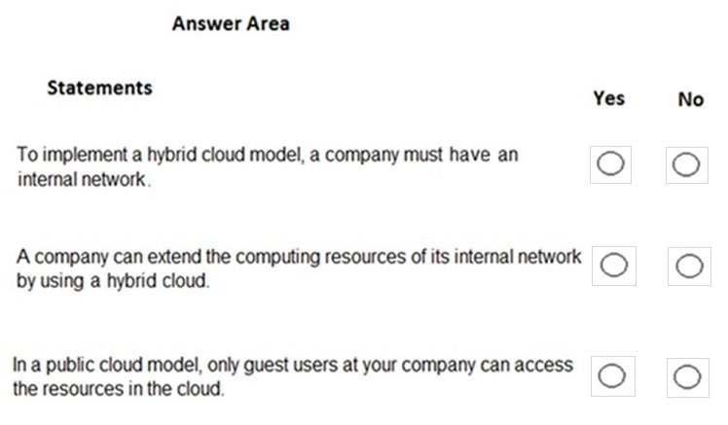

**No, Yes, No**

# Question #56

HOTSPOT -  
For each of the following statements, select Yes if the statement is true. Otherwise, select No.  
NOTE: Each correct selection is worth one point.  
Hot Area:  
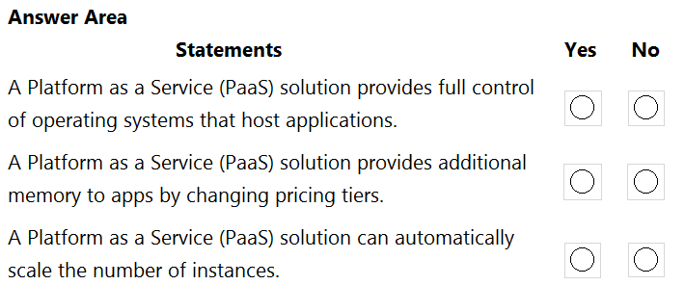

**No, No, Yes**

# Question #57

Your company has an on-premises network that contains multiple servers.  
The company plans to reduce the following administrative responsibilities:  
✑ Backing up application data  
✑ Replacing failed server hardware  
✑ Managing physical server security  
✑ Updating server operating systems  
✑ Managing permissions to shared documents  
The company plans to migrate servers to Azure virtual machines.  
You need to identify which administrative responsibilities will be eliminated after the planned migration.  
Which two responsibilities should you identify? Each correct answer presents a complete solution.  
NOTE: Each correct selection is worth one point.

* A. Replacing failed server hardware
* B. Backing up application data
* C. Managing physical server security
* D. Updating server operating systems
* E. Managing permissions to shared documents

**A,C**

# Question #58

HOTSPOT -  
For each of the following statements, select Yes if the statement is true. Otherwise, select No.  
NOTE: Each correct selection is worth one point.  
Hot Area:  
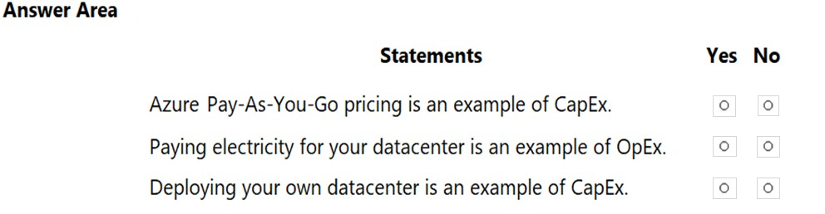

**No, Yes, Yes**

# Question #59

You plan to provision Infrastructure as a Service (IaaS) resources in Azure.  
Which resource is an example of IaaS?

* A. an Azure web app
* B. an Azure virtual machine
* C. an Azure logic app
* D. an Azure SQL database

**B**

# Question #60

To which cloud models can you deploy physical servers?

* A. private cloud and hybrid cloud only
* B. private cloud only
* C. private cloud, hybrid cloud and public cloud
* D. hybrid cloud only

**A**

# Question #61

DRAG DROP -  
Match the cloud model to the correct advantage.  
Instructions: To answer, drag the appropriate cloud model from the column on the left to its advantage on the right. Each cloud model may be used once, more than once, or not at all.  
NOTE: Each correct match is worth one point  
Select and Place:  
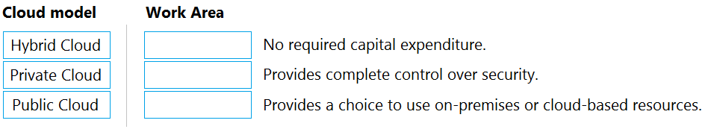

**Public Cloud, Private Cloud, Hybrid Cloud.**

# Question #62

HOTSPOT -  
For each of the following statements, select Yes if the statement is true. Otherwise, select No.  
NOTE: Each correct selection is worth one point.  
Hot Area:  
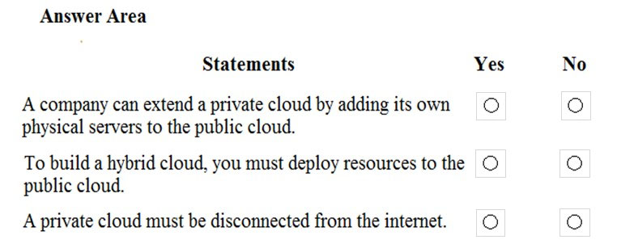

No, Yes, No

# Question #63

You have 50 virtual machines hosted on-premises and 50 virtual machines hosted in Azure. The on-premises virtual machines and the Azure virtual machines connect to each other.  
Which type of cloud model is this?

* A. hybrid
* B. private
* C. public

**A**

# Question #64

HOTSPOT -  
For each of the following statements, select Yes if the statement is true. Otherwise, select No.  
NOTE: Each correct selection is worth one point.  
Hot Area:  
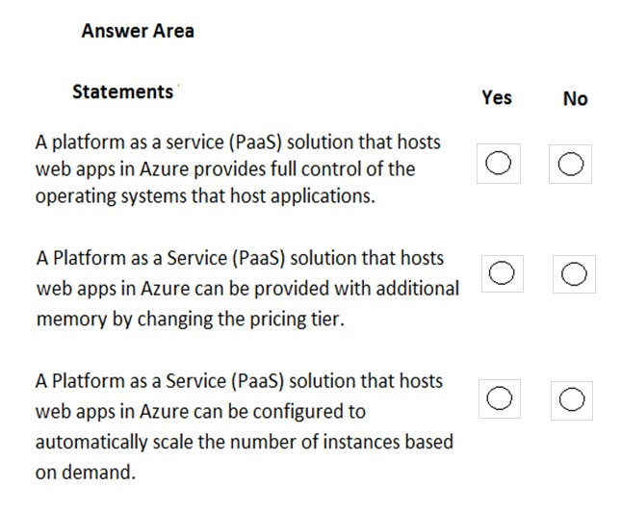

**No, Yes, Yes**

# Question #65

Note: This question is part of a series of questions that present the same scenario. Each question in the series contains a unique solution that might meet the stated goals. Some question sets might have more than one correct solution, while others might not have a correct solution.  
After you answer a question in this section, you will NOT be able to return to it. As a result, these questions will not appear in the review screen.  
Your company plans to migrate all its data and resources to Azure.  
The companyג€™s migration plan states that only Platform as a Service (PaaS) solutions must be used in Azure.  
You need to deploy an Azure environment that meets the company migration plan.  
Solution: You create Azure virtual machines, Azure SQL databases, and Azure Storage accounts.  
Does this meet the goal?

* A. Yes
* B. No

**B**

# Question #66

Your company plans to deploy several custom applications to Azure. The applications will provide invoicing services to the customers of the company. Each application will have several prerequisite applications and services installed.  
You need to recommend a cloud deployment solution for all the applications.  
What should you recommend?

* A. Software as a Service (SaaS)
* B. Platform as a Service (PaaS)
* C. Infrastructure as a Service (laaS)

**C**

# Question #67

HOTSPOT -  
For each of the following statements, select Yes if the statement is true. Otherwise, select No.  
NOTE: Each correct selection is worth one point.  
Hot Area:  
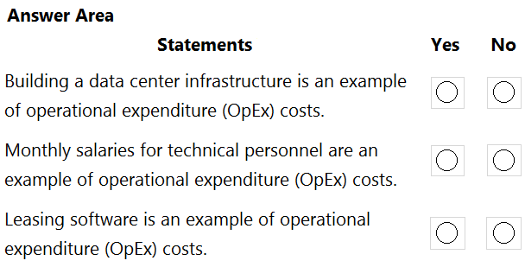

**No, Yes, Yes**

# Question #68

HOTSPOT -  
To complete the sentence, select the appropriate option in the answer area.  
Hot Area:  
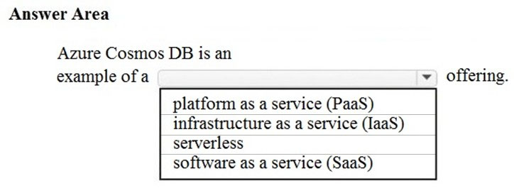

Platform as a service (PaaS)

# Question #69

HOTSPOT -  
For each of the following statements, select Yes if the statement is true. Otherwise, select No.  
NOTE: Each correct selection is worth one point.  
Hot Area:  
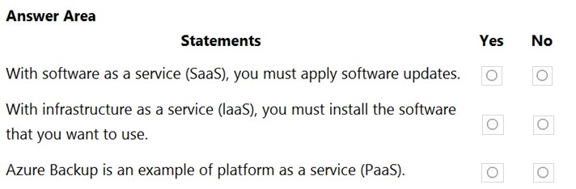

No, Yes, Yes

# Question #70

HOTSPOT -  
For each of the following statements, select Yes if the statement is true. Otherwise, select No.  
NOTE: Each correct selection is worth one point.  
Hot Area:  
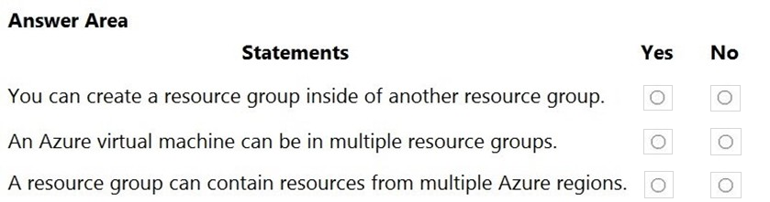

No, No, Yes

# Question #71

HOTSPOT -  
For each of the following statements, select Yes if the statement is true. Otherwise, select No.  
NOTE: Each correct selection is worth one point.  
Hot Area:  
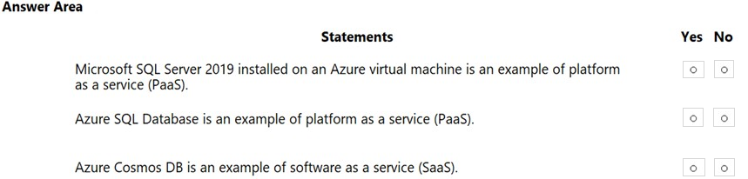

No, Yes, No

# Question #72

HOTSPOT -  
To complete the sentence, select the appropriate option in the answer area.  
Hot Area:  
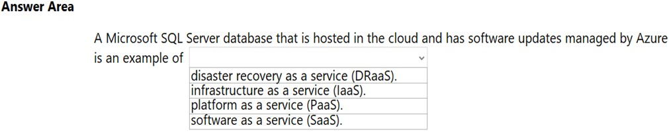

Platform as a service (PaaS)

# Question #73

Your company plans to migrate all its data and resources to Azure.  
The companyג€™s migration plan states that only Platform as a Service (PaaS) solutions must be used in Azure.  
You need to deploy an Azure environment that meets the companyג€™s migration plan.  
What should you create?

* A. Azure virtual machines, Azure SQL databases, and Azure Storage accounts.
* B. an Azure App Service and Azure virtual machines that have Microsoft SQL Server installed.
* C. an Azure App Service and Azure SQL databases.
* D. Azure storage accounts and web server in Azure virtual machines.

C

# Question #74

What does a customer provide in a software as a service (SaaS) model?

* A. application data
* B. data storage
* C. compute resources
* D. application software

A

# Question #75

HOTSPOT -  
For each of the following statements, select Yes if the statement is true. Otherwise, select No.  
NOTE: Each correct selection is worth one point.  
Hot Area:  
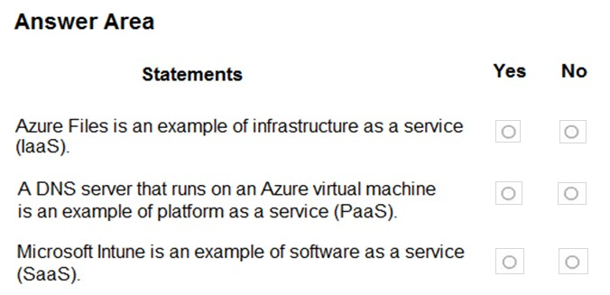

Yes, No, Yes

# Question #76

HOTSPOT -  
For each of the following statements, select Yes if the statement is true. Otherwise, select No.  
NOTE: Each correct selection is worth one point.  
Hot Area:  
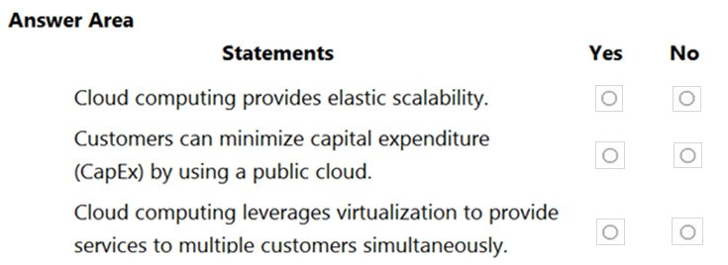

Yes, Yes, Yes

# Question #77

What is the first stage in the Microsoft Cloud Adoption Framework for Azure?

* A. Adopt the cloud.
* B. Make a plan.
* C. Ready your organization.
* D. Define your strategy.

D

Strategy: Define business justification and expected outcomes of adoption.

Plan: Align actionable adoption plans to business outcomes.

Ready: Prepare the cloud environment for the planned changes.

Migrate: Migrate and modernize existing workloads.

Innovate: Develop new cloud-native or hybrid solutions.

Govern: Govern the environment and workloads.

Manage: Operations management for cloud and hybrid solutions.

Organize: Align the teams and roles supporting your organization's cloud adoption efforts.

# Question #78

HOTSPOT -  
For each of the following statements, select Yes if the statement is true. Otherwise, select No.  
NOTE: Each correct selection is worth one point.  
Hot Area:  
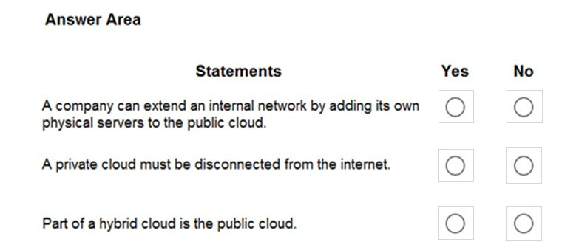

No, No, Yes

# Question #79

HOTSPOT -  
To complete the sentence, select the appropriate option in the answer area.  
Hot Area:  
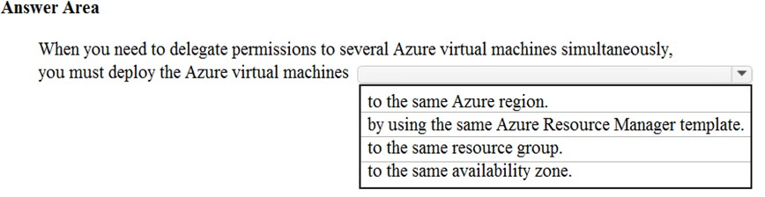

to the same resource group

# Question #80

Note: This question is part of a series of questions that present the same scenario. Each question in the series contains a unique solution that might meet the stated goals. Some question sets might have more than one correct solution, while others might not have a correct solution.  
After you answer a question in this section, you will NOT be able to return to it. As a result, these questions will not appear in the review screen.  
You plan to deploy several Azure virtual machines.  
You need to ensure that the services running on the virtual machines are available if a single data center fails.  
Solution: You deploy the virtual machines to two or more availability zones.  
Does this meet the goal?

* A. Yes
* B. No

A

# Question #81

This question requires that you evaluate the underlined text to determine if it is correct.  
One of the benefits of Azure SQL Data Warehouse is that high availability is built into the platform.  
Instructions: Review the underlined text. If it makes the statement correct, select ג€No change is neededג€. If the statement is incorrect, select the answer choice that makes the statement correct.

* A. No change is needed
* B. automatic scaling
* C. data compression
* D. versioning

A

# Question #82

Note: This question is part of a series of questions that present the same scenario. Each question in the series contains a unique solution that might meet the stated goals. Some question sets might have more than one correct solution, while others might not have a correct solution.  
After you answer a question in this section, you will NOT be able to return to it. As a result, these questions will not appear in the review screen.  
You plan to deploy several Azure virtual machines.  
You need to ensure that the services running on the virtual machines are available if a single data center fails.  
Solution: You deploy the virtual machines to two or more regions.  
Does this meet the goal?

* A. Yes
* B. No

A

# Question #83

HOTSPOT -  
For each of the following statements, select Yes if the statement is true. Otherwise, select No.  
NOTE: Each correct selection is worth one point.  
Hot Area:  
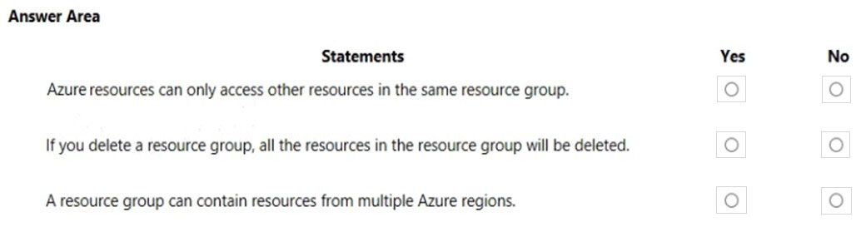

No, Yes, Yes

# Question #84

You plan to store 20 TB of data in Azure. The data will be accessed infrequently and visualized by using Microsoft Power BI.  
You need to recommend a storage solution for the data.  
Which two solutions should you recommend? Each correct answer presents a complete solution.  
NOTE: Each correct selection is worth one point.

* A. Azure Data Lake
* B. Azure Cosmos DB
* C. Azure SQL Data Warehouse
* D. Azure SQL Database
* E. Azure Database for PostgreSQL

A, C

# Question #85

HOTSPOT -  
You have an Azure environment that contains 10 web apps. To which URL should you connect to manage all the Azure resources? To answer, select the appropriate options in the answer area.  
NOTE: Each correct selection is worth one point.  
Hot Area:  
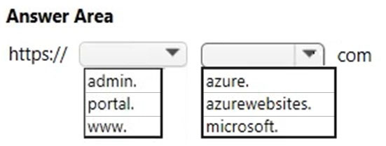

Portal.azure

# Question #86

You need to identify the type of failure for which an Azure Availability Zone can be used to protect access to Azure services.  
What should you identify?

* A. a physical server failure
* B. an Azure region failure
* C. a storage failure
* D. an Azure data center failure

D Regions > Zones > Datacenters

# Question #87

HOTSPOT -  
You plan to extend your companyג€™s network to Azure.  
The network contains a VPN appliance that uses an IP address of 131.107.200.1.  
You need to create an Azure resource that defines the VPN appliance in Azure.  
Which Azure resource should you create? To answer, select the appropriate resource in the answer area.  
Hot Area:  
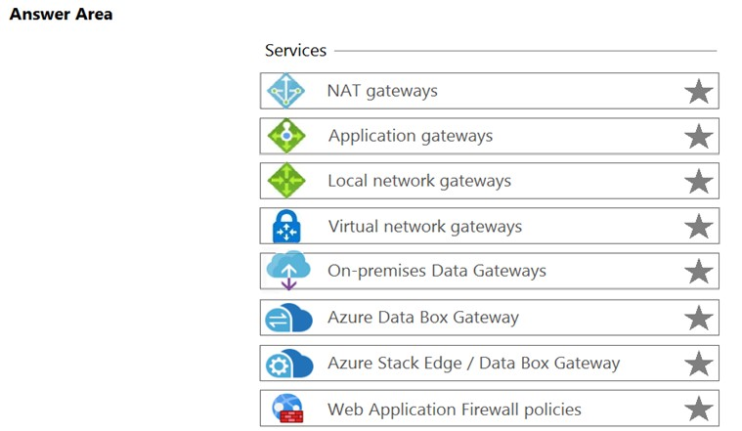

local network gateways

In Azure, a Virtual Network Gateway is only required when you are using Azure's native P2S VPN, S2S VPN, or an ExpressRoute. A Local Network Gateway is part of a Virtual Network Gateway, and is used to describe connected address spaces for routing.

# Question #88

Note: This question is part of a series of questions that present the same scenario. Each question in the series contains a unique solution that might meet the stated goals. Some question sets might have more than one correct solution, while others might not have a correct solution.  
After you answer a question in this section, you will NOT be able to return to it. As a result, these questions will not appear in the review screen.  
You plan to deploy several Azure virtual machines.  
You need to ensure that the services running on the virtual machines are available if a single data center fails.  
Solution: You deploy the virtual machines to two or more resource groups.  
Does this meet the goal?

* A. Yes
* B. No

B

# Question #89

Note: This question is part of a series of questions that present the same scenario. Each question in the series contains a unique solution that might meet the stated goals. Some question sets might have more than one correct solution, while others might not have a correct solution.  
After you answer a question in this section, you will NOT be able to return to it. As a result, these questions will not appear in the review screen.  
You plan to deploy several Azure virtual machines.  
You need to ensure that the services running on the virtual machines are available if a single data center fails.  
Solution: You deploy the virtual machines to a scale set.  
Does this meet the goal?

* A. Yes
* B. No

B

# Question #90

HOTSPOT -  
For each of the following statements, select Yes if the statement is true. Otherwise, select No.  
NOTE: Each correct selection is worth one point.  
Hot Area:  
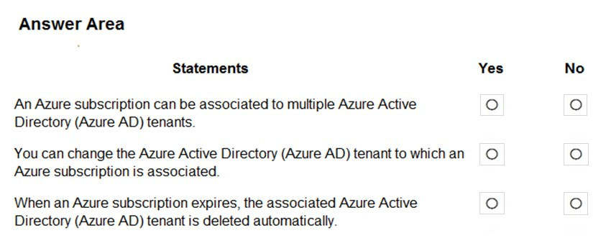

No, Yes, No

# Question #91

This question requires that you evaluate the underlined text to determine if it is correct.  
Resource groups provide organizations with the ability to manage the compliance of Azure resources across multiple subscriptions.  
Instructions: Review the underlined text. If it makes the statement correct, select ג€No change is neededג€. If the statement is incorrect, select the answer choice that makes the statement correct.

* A. No change is needed
* B. Management groups
* C. Azure policies
* D. Azure App Service plans

C

# Question #92

Your company plans to migrate to Azure.  
The company has several departments. All the Azure resources used by each department will be managed by a department administrator.  
What are two possible techniques to segment Azure for the departments? Each correct answer presents a complete solution.  
NOTE: Each correct selection is worth one point.

* A. multiple subscriptions
* B. multiple Azure Active Directory (Azure AD) directories
* C. multiple regions
* D. multiple resource groups

A, D

# Question #93

HOTSPOT -  
For each of the following statements, select Yes if the statement is true. Otherwise, select No.  
NOTE: Each correct selection is worth one point.  
Hot Area:  
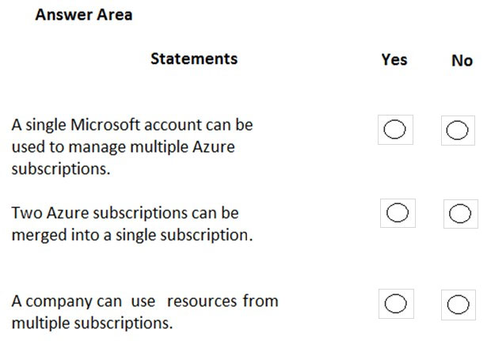

Yes, No, Yes

# Question #94

HOTSPOT -  
To complete the sentence, select the appropriate option in the answer area.  
Hot Area:  
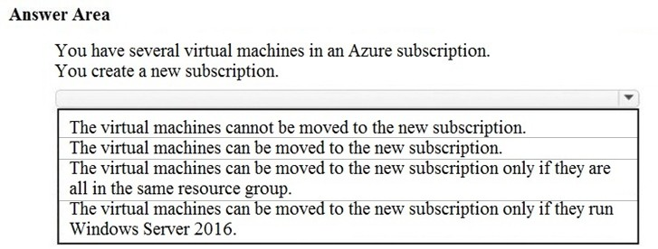

The virtual machines can be moved to the new subscription.

# Question #95

You have an Azure environment that contains multiple Azure virtual machines.  
You plan to implement a solution that enables the client computers on your on-premises network to communicate to the Azure virtual machines.  
You need to recommend which Azure resources must be created for the planned solution.  
Which two Azure resources should you include in the recommendation? Each correct answer presents part of the solution.  
NOTE: Each correct selection is worth one point.

* A. a virtual network gateway
* B. a load balancer
* C. an application gateway
* D. a virtual network
* E. a gateway subnet

A, E

# Question #96

You attempt to create several managed Microsoft SQL Server instances in an Azure environment and receive a message that you must increase your Azure subscription limits.  
What should you do to increase the limits?

* A. Create a service health alert
* B. Upgrade your support plan
* C. Modify an Azure policy
* D. Create a new support request

D

# Question #97

HOTSPOT -  
For each of the following statements, select Yes if the statement is true. Otherwise, select No.  
NOTE: Each correct selection is worth one point.  
Hot Area:  
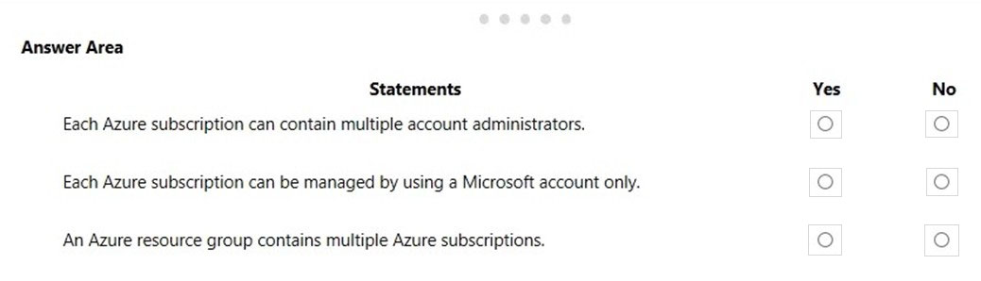

Yes, No, No

# Question #98

HOTSPOT -  
For each of the following statements, select Yes if the statement is true. Otherwise, select No.  
NOTE: Each correct selection is worth one point.  
Hot Area:  
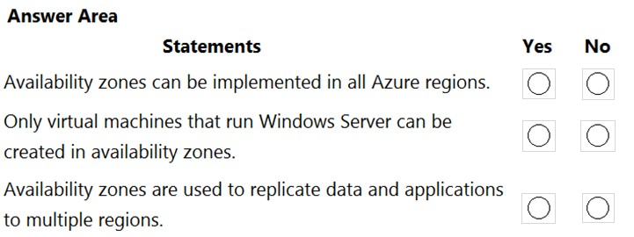

No, No, No

# Question #99

HOTSPOT -  
You plan to create an Azure virtual machine.  
You need to identify which storage service must be used to store the unmanaged data disks of the virtual machine.  
What should you identify? To answer, select the appropriate service in the answer area.  
Hot Area:  
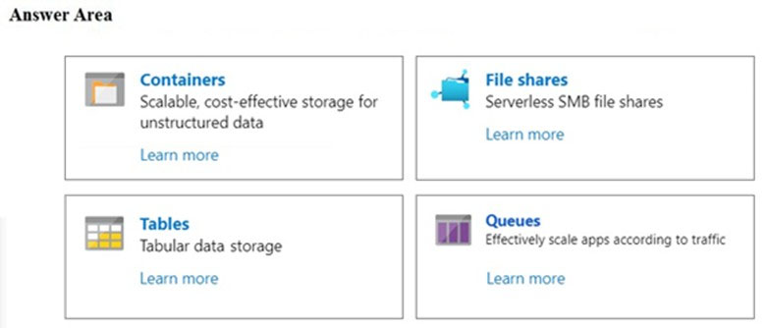

Containers

# Question #100

Your company plans to move several servers to Azure.  
The companyג€™s compliance policy states that a server named FinServer must be on a separate network segment.  
You are evaluating which Azure services can be used to meet the compliance policy requirements.  
Which Azure solution should you recommend?

* A. a resource group for FinServer and another resource group for all the other servers
* B. a virtual network for FinServer and another virtual network for all the other servers
* C. a VPN for FinServer and a virtual network gateway for each other server
* D. one resource group for all the servers and a resource lock for FinServer

B

# Question #101

You plan to map a network drive from several computers that run Windows 10 to Azure Storage.  
You need to create a storage solution in Azure for the planned mapped drive.  
What should you create?

* A. an Azure SQL database
* B. a virtual machine data disk
* C. a File service in a storage account
* D. a Blob service in a storage account

C

# Question #102

HOTSPOT -  
You plan to implement an Azure database solution.  
You need to implement a database solution that meets the following requirements:  
✑ Can add data concurrently from multiple regions  
✑ Can store JSON documents  
Which database service should you deploy? To answer, select the appropriate service in the answer area.  
Hot Area:  
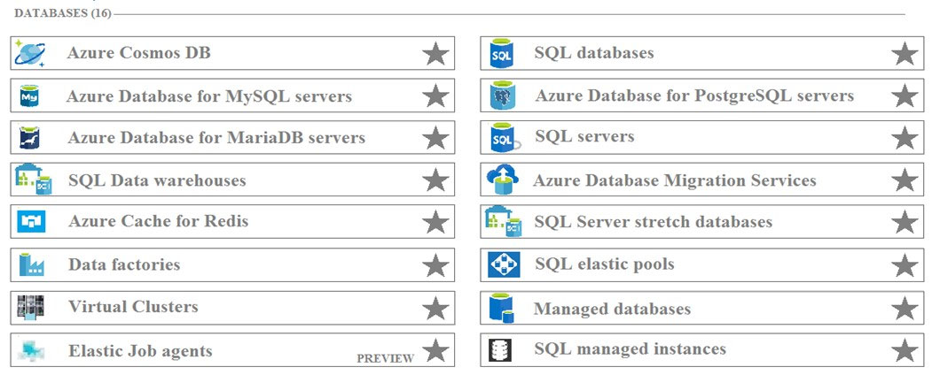

Azure Cosmos DB

# Question #103

Your company plans to start using Azure and will migrate all its network resources to Azure.  
You need to start the planning process by exploring Azure.  
What should you create first?

* A. a subscription
* B. a resource group
* C. a virtual network
* D. a management group

A

# Question #104

HOTSPOT -  
For each of the following statements, select Yes if the statement is true. Otherwise, select No.  
NOTE: Each correct selection is worth one point.  
Hot Area:  
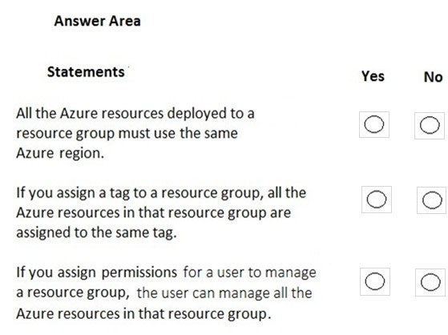

No, No, Yes

# Question #105

HOTSPOT -  
To complete the sentence, select the appropriate option in the answer area.  
Hot Area:  
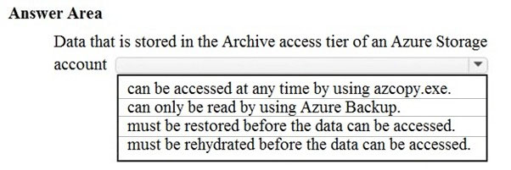

Must be rehydrated before the data can be accessed

# Question #106

HOTSPOT -  
You plan to deploy a critical line-of-business application to Azure.  
The application will run on an Azure virtual machine.  
You need to recommend a deployment solution for the application. The solution must provide a guaranteed availability of 99.99 percent.  
What is the minimum number of virtual machines and the minimum number of availability zones you should recommend for the deployment? To answer, select the appropriate options in the answer area.  
NOTE: Each correct selection is worth one point.  
Hot Area:  
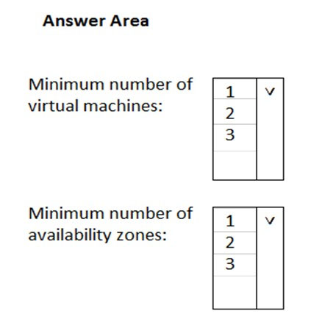

2, 2

# Question #107

Which Azure service should you use to collect events from multiple resources into a centralized repository?

* A. Azure Event Hubs
* B. Azure Analysis Services
* C. Azure Monitor
* D. Azure Stream Analytics

A

# Question #108

HOTSPOT -  
To complete the sentence, select the appropriate option in the answer area.  
Hot Area:  
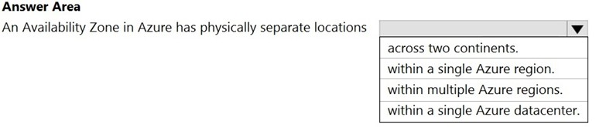

Within a single azure region.

# Question #109

HOTSPOT -  
For each of the following statements, select Yes if the statement is true. Otherwise, select No.  
NOTE: Each correct selection is worth one point.  
Hot Area:  
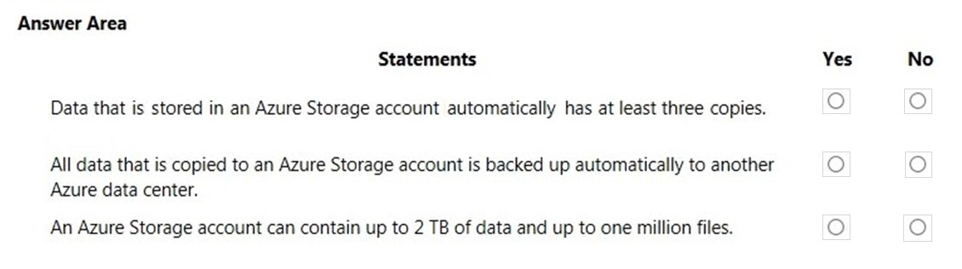

Yes, No, No

# Question #110

HOTSPOT -  
For each of the following statements, select Yes if the statement is true. Otherwise, select No.  
NOTE: Each correct selection is worth one point.  
Hot Area:  
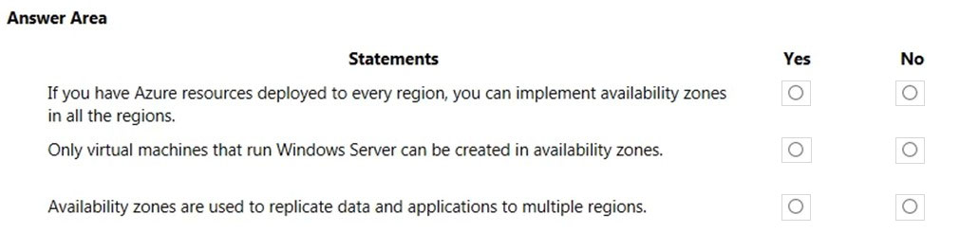

No, No, No

# Question #111

HOTSPOT -  
For each of the following statements, select Yes if the statement is true. Otherwise, select No.  
NOTE: Each correct selection is worth one point.  
Hot Area:  
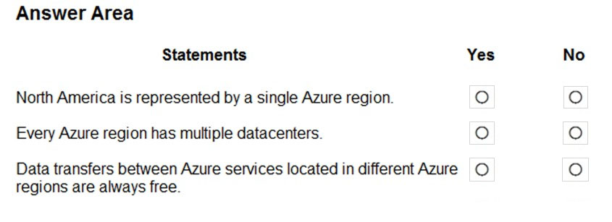

No, Yes, No

# Question #112

Note: This question is part of a series of questions that present the same scenario. Each question in the series contains a unique solution that might meet the stated goals. Some question sets might have more than one correct solution, while others might not have a correct solution.  
After you answer a question in this section, you will NOT be able to return to it. As a result, these questions will not appear in the review screen.  
You plan to deploy several Azure virtual machines.  
You need to ensure that the services running on the virtual machines are available if a single data center fails.  
Solution: You deploy the virtual machines to two or more scale sets.  
Does this meet the goal?

* A. Yes
* B. No

B

# Question #113

You need to be notified when Microsoft plans to perform maintenance that can affect the resources deployed to an Azure subscription.  
What should you use?

* A. Azure Monitor
* B. Azure Service Health
* C. Azure Advisor
* D. Microsoft Trust Center

B

# Question #114

DRAG DROP -  
Match the Azure Services service to the correct description.  
Instructions: To answer, drag the appropriate service from the column on the left to its description on the right. Each service may be used once, more than once, or not at all.  
NOTE: Each correct selection is worth one point.  
Select and Place:  
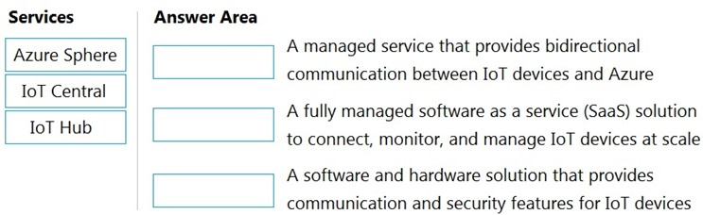

IoT Hub, IoT Central, Azure Sphere

# Question #115

HOTSPOT -  
For each of the following statements, select Yes if the statement is true. Otherwise, select No.  
NOTE: Each correct selection is worth one point.  
Hot Area:  
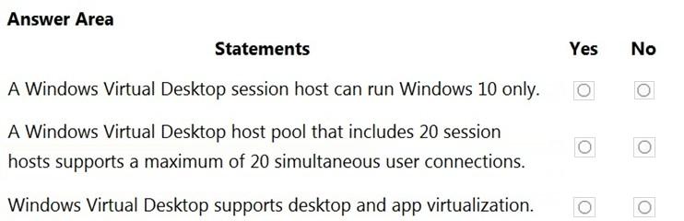

No, No, Yes

# Question #116

HOTSPOT -  
To complete the sentence, select the appropriate option in the answer area.  
Hot Area:  
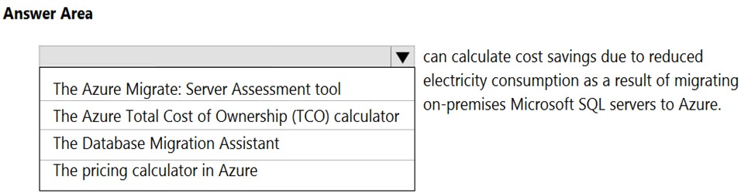

The Azure Total Cost of Ownership (TCO) calculator

# Question #117

HOTSPOT -  
For each of the following statements, select Yes if the statement is true. Otherwise, select No.  
NOTE: Each correct selection is worth one point.  
Hot Area:  
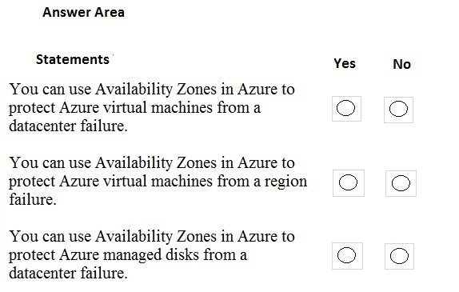

Yes, No, Yes

# Question #118

HOTSPOT -  
For each of the following statements, select Yes if the statement is true. Otherwise, select No.  
NOTE: Each correct selection is worth one point.  
Hot Area:  
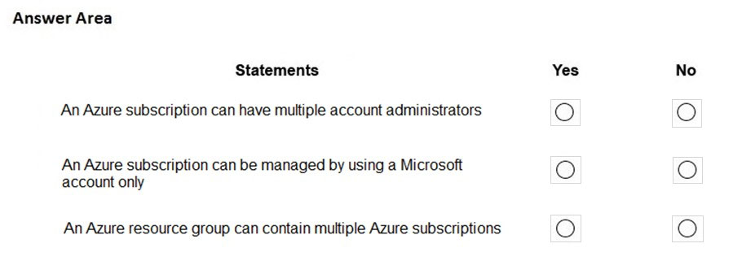

Yes, No, No

# Question #119

HOTSPOT -  
To complete the sentence, select the appropriate option in the answer area.  
Hot Area:  
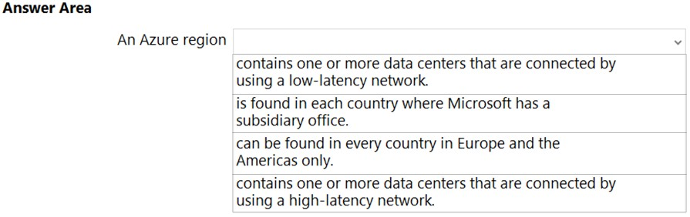

Contains one or more data centers that are connected by using a low-latency network.

# Question #120

HOTSPOT -  
For each of the following statements, select Yes if the statement is true. Otherwise, select No.  
NOTE: Each correct selection is worth one point.  
Hot Area:  
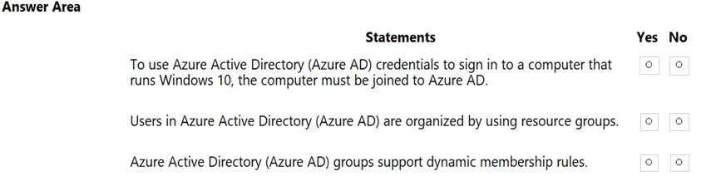

Yes, No, Yes

# Question #121

You plan to deploy several Azure virtual machines.  
You need to ensure that the services running on the virtual machines remain available if a single data center fails.  
What are two possible solutions? Each correct answer presents a complete solution.

* A. Deploy the virtual machines to two or more availability zones.
* B. Deploy the virtual machines to two or more resource groups.
* C. Deploy the virtual machines to a scale set.
* D. Deploy the virtual machines to two or more regions.

A, D

# Question #122

HOTSPOT -  
To complete the sentence, select the appropriate option in the answer area.  
Hot Area:  
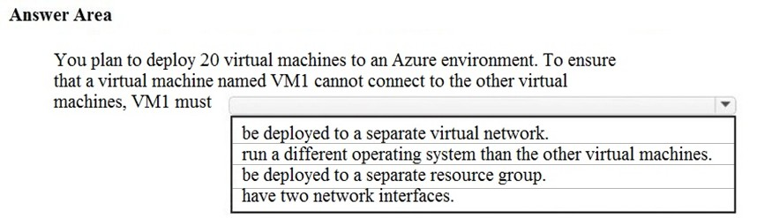

Be deployed to a separate virtual network.

# Question #123

DRAG DROP -  
Match the Azure service to the appropriate description.  
To answer, drag the appropriate service from the column on the left to its description on the right. Each service may be used once, more than once, or not at all.  
NOTE: Each correct match is worth one point.  
Select and Place:  
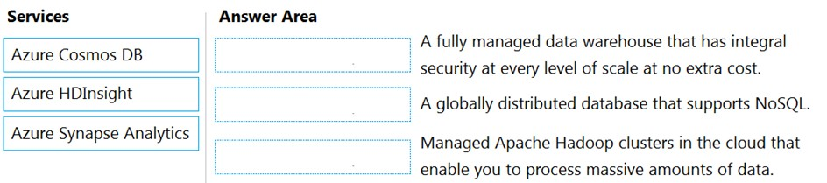

Azure Synapse Analytics, Azure Cosmos DB, Azure HDInsight

# Question #124

HOTSPOT -  
For each of the following statements, select Yes if the statement is true. Otherwise, select No.  
NOTE: Each correct selection is worth one point.  
Hot Area:  
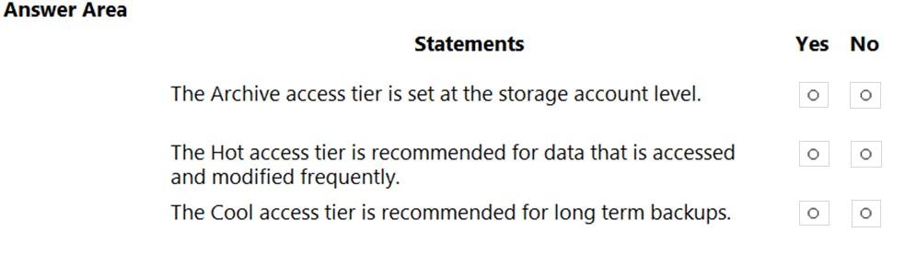

Yes, Yes, No

# Question #125

What is the most severe failure from which an Azure Availability Zone can be used to protect access to Azure service?

* A. a physical server failure
* B. an Azure region failure
* C. a storage failure
* D. an Azure data center failure

D

# Question #126

You need to purchase a third-party virtual security appliance that you will deploy to an Azure subscription.  
What should you use?

* A. Azure subscriptions
* B. Azure Security Center
* C. Azure Marketplace
* D. Microsoft Store

C

# Question #127

DRAG DROP -  
Match the serverless solution to the correct characteristic.  
To answer, drag the appropriate serverless solution from the column on the left to its characteristic on the right. Each serverless solution may be used once, more than once, or not at all.  
NOTE: Each correct match is worth one point.  
Select and Place:  
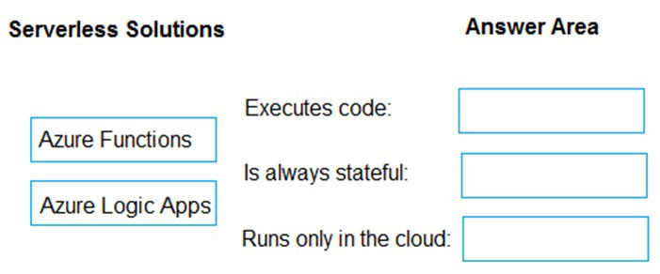

Azure Functions, Azure Logic Apps, Azure Logic Apps

# Question #128

HOTSPOT -  
Select the answer that correctly completes the sentence.  
Hot Area:  
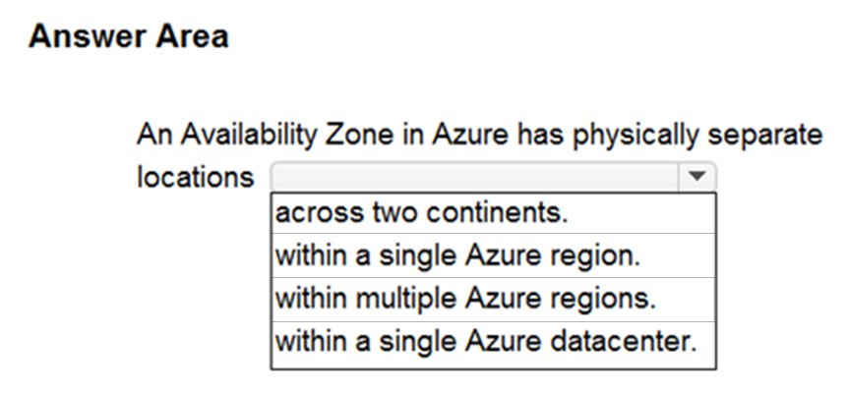

Within a single Azure region

# Question #129

DRAG DROP -  
Match the Azure service to the correct definition.  
Instructions: To answer, drag the appropriate Azure service from the column on the left to its description on the right. Each service may be used once, more than once, or not at all.  
NOTE: Each correct selection is worth one point.  
Select and Place:  
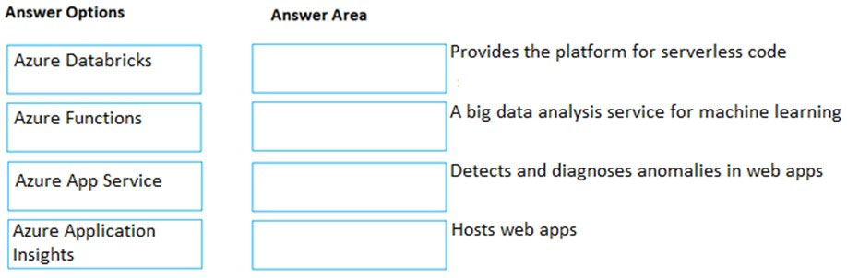

Azure Functions, Azure Databricks, Azure Application Insights, Azure App Service

# Question #130

A team of developers at your company plans to deploy, and then remove, 50 customized virtual machines each week. Thirty of the virtual machines run Windows  
Server 2016 and 20 of the virtual machines run Ubuntu Linux.  
You need to recommend which Azure service will minimize the administrative effort required to deploy and remove the virtual machines.  
What should you recommend?

* A. Azure Reserved Virtual Machines (VM) Instances
* B. Azure virtual machine scale sets
* C. Azure DevTest Labs
* D. Microsoft Managed Desktop

C

# Question #131

HOTSPOT -  
For each of the following statements, select Yes if the statement is true. Otherwise, select No.  
NOTE: Each correct selection is worth one point.  
Hot Area:  
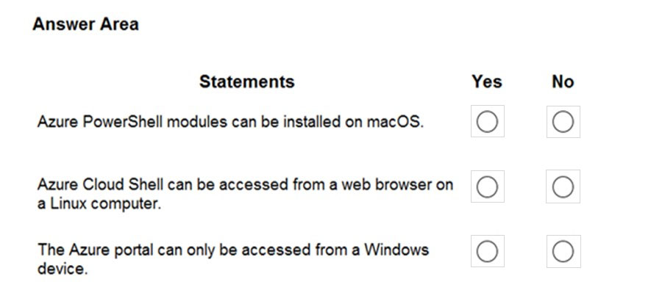

Yes, Yes, No

# Question #132

A support engineer plans to perform several Azure management tasks by using the Azure CLI.  
You install the CLI on a computer.  
You need to tell the support engineer which tools to use to run the CLI.  
Which two tools should you instruct the support engineer to use? Each correct answer presents a complete solution.  
NOTE: Each correct selection is worth one point.

* A. Command Prompt
* B. Azure Resource Explorer
* C. Windows PowerShell
* D. Windows Defender Firewall
* E. Network and Sharing Center

A, C

# Question #133

Note: This question is part of a series of questions that present the same scenario. Each question in the series contains a unique solution that might meet the stated goals. Some question sets might have more than one correct solution, while others might not have a correct solution.  
After you answer a question in this section, you will NOT be able to return to it. As a result, these questions will not appear in the review screen.  
You have an Azure environment. You need to create a new Azure virtual machine from a tablet that runs the Android operating system.  
Solution: You use PowerShell in Azure Cloud Shell.  
Does this meet the goal?

* A. Yes
* B. No

A

# Question #134

Note: This question is part of a series of questions that present the same scenario. Each question in the series contains a unique solution that might meet the stated goals. Some question sets might have more than one correct solution, while others might not have a correct solution.  
After you answer a question in this section, you will NOT be able to return to it. As a result, these questions will not appear in the review screen.  
You have an Azure environment. You need to create a new Azure virtual machine from a tablet that runs the Android operating system.  
Solution: You use the PowerApps portal.  
Does this meet the goal?

* A. Yes
* B. No

B

# Question #135

Note: This question is part of a series of questions that present the same scenario. Each question in the series contains a unique solution that might meet the stated goals. Some question sets might have more than one correct solution, while others might not have a correct solution.  
After you answer a question in this section, you will NOT be able to return to it. As a result, these questions will not appear in the review screen.  
You have an Azure environment. You need to create a new Azure virtual machine from a tablet that runs the Android operating system.  
Solution: You use the Azure portal.  
Does this meet the goal?

* A. Yes
* B. No

A

# Question #136

HOTSPOT -  
To complete the sentence, select the appropriate option in the answer area.  
Hot Area:  
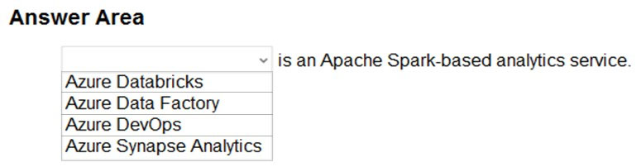

Azure Databricks

# Question #137

HOTSPOT -  
For each of the following statements, select Yes if the statement is true. Otherwise, select No.  
NOTE: Each correct selection is worth one point.  
Hot Area:  
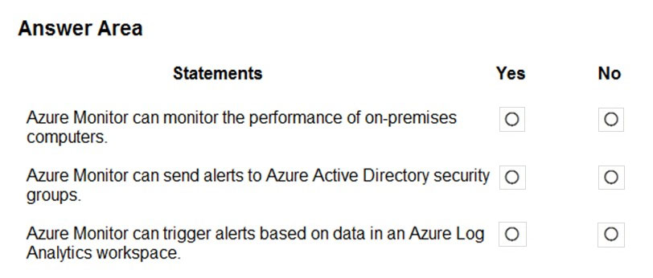

Yes, No, Yes

# Question #138

Which Azure service provides a set of version control tools to manage code?

* A. Azure Repos
* B. Azure DevTest Labs
* C. Azure Storage
* D. Azure Cosmos DB

A

# Question #139

HOTSPOT -  
You need to manage Azure by using Azure Cloud Shell.  
Which Azure portal icon should you select? To answer, select the appropriate icon in the answer area.  
Hot Area:  
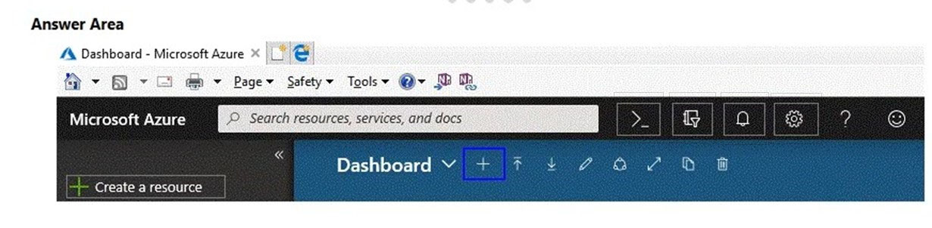

>_

# Question #140

You have a virtual machine named VM1 that runs Windows Server 2016. VM1 is in the East US Azure region.  
Which Azure service should you use from the Azure portal to view service failure notifications that can affect the availability of VM1?

* A. Azure Service Fabric
* B. Azure Monitor
* C. Azure virtual machines
* D. Azure Advisor

C

# Question #141

Note: This question is part of a series of questions that present the same scenario. Each question in the series contains a unique solution that might meet the stated goals. Some question sets might have more than one correct solution, while others might not have a correct solution.  
After you answer a question in this section, you will NOT be able to return to it. As a result, these questions will not appear in the review screen.  
An Azure administrator plans to run a PowerShell script that creates Azure resources.  
You need to recommend which computer configuration to use to run the script.  
Solution: Run the script from a computer that runs Linux and has the Azure CLI tools installed.  
Does this meet the goal?

* A. Yes
* B. No

B

# Question #142

Note: This question is part of a series of questions that present the same scenario. Each question in the series contains a unique solution that might meet the stated goals. Some question sets might have more than one correct solution, while others might not have a correct solution.  
After you answer a question in this section, you will NOT be able to return to it. As a result, these questions will not appear in the review screen.  
An Azure administrator plans to run a PowerShell script that creates Azure resources.  
You need to recommend which computer configuration to use to run the script.  
Solution: Run the script from a computer that runs Chrome OS and uses Azure Cloud Shell.  
Does this meet the goal?

* A. Yes
* B. No

A

# Question #143

HOTSPOT -  
For each of the following statements, select Yes if the statement is true. Otherwise, select No.  
NOTE: Each correct selection is worth one point.  
Hot Area:  
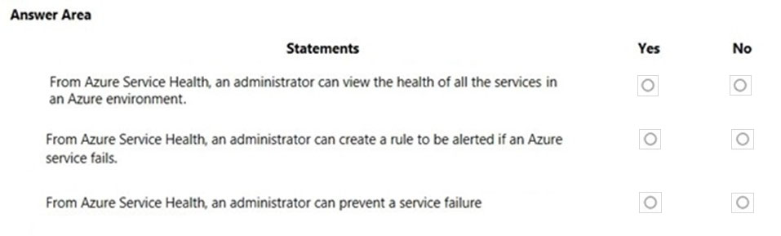

Yes, Yes, No

# Question #144

Note: This question is part of a series of questions that present the same scenario. Each question in the series contains a unique solution that might meet the stated goals. Some question sets might have more than one correct solution, while others might not have a correct solution.  
After you answer a question in this section, you will NOT be able to return to it. As a result, these questions will not appear in the review screen.  
An Azure administrator plans to run a PowerShell script that creates Azure resources.  
You need to recommend which computer configuration to use to run the script.  
Solution: Run the script from a computer that runs macOS and has PowerShell Core 6.0 installed.  
Does this meet the goal?

* A. Yes
* B. No

A

# Question #145

HOTSPOT -  
You need to view a list of planned maintenance events that can affect the availability of an Azure subscription.  
Which blade should you use from the Azure portal? To answer, select the appropriate blade in the answer area.  
Hot Area:  
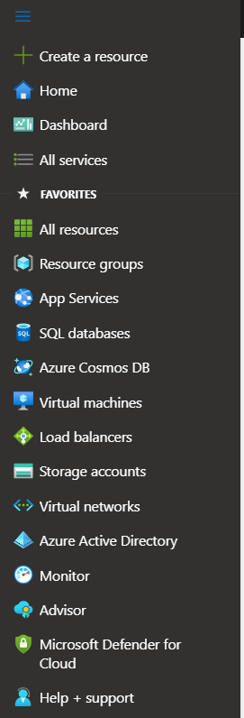

Help + Support

# Question #146

DRAG DROP -  
Match the Azure service to the correct definition.  
Instructions: To answer, drag the appropriate Azure service from the column on the left to its description on the right. Each service may be used once, more than once, or not at all.  
NOTE: Each correct match is worth one point.  
Select and Place:  
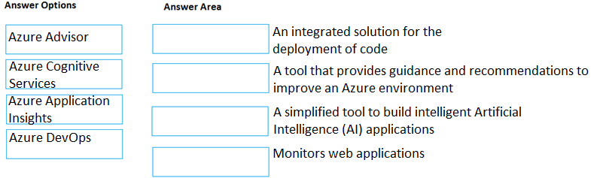

Azure DevOps, Azure Advisor, Azure Cognitive Services, Azure Application Insights

# Question #147

DRAG DROP -  
Match the Azure service to the correct description.  
Instructions: To answer, drag the appropriate Azure service from the column on the left to its description on the right. Each service may be used once, more than once, or not at all.  
NOTE: Each correct match is worth one point.  
Select and Place:  
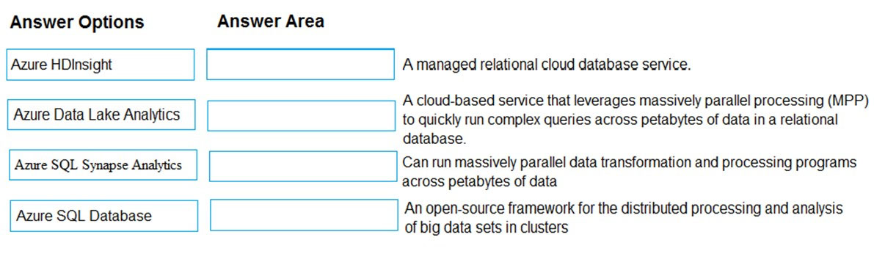

Azure SQL Database, Azure SQL Synapse Analytics , Azure Data Lake Analytics, Azure HDInsight

# Question #148

HOTSPOT -  
You need to identify which blades in the Azure portal must be used to perform the following tasks:  
✑ View security recommendations.  
✑ Monitor the health of Azure services.  
✑ Browse available virtual machine images.  
Which blade should you identify for each task? To answer, select the appropriate options in the answer area.  
NOTE: Each correct selection is worth one point.  
Hot Area:  
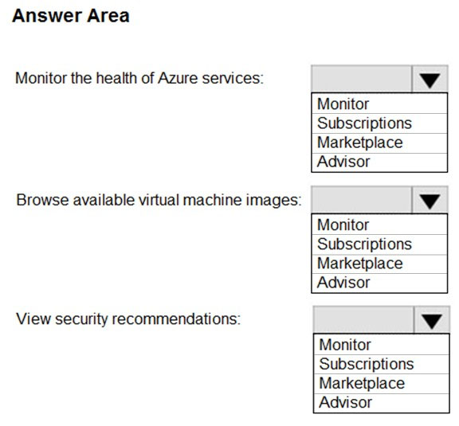

Monitor, Marketplace, Advisor

# Question #149

Note: This question is part of a series of questions that present the same scenario. Each question in the series contains a unique solution that might meet the stated goals. Some question sets might have more than one correct solution, while others might not have a correct solution.  
After you answer a question in this section, you will NOT be able to return to it. As a result, these questions will not appear in the review screen.  
You have an Azure environment. You need to create a new Azure virtual machine from a tablet that runs the Android operating system.  
Solution: You use Bash in Azure Cloud Shell.  
Does this meet the goal?

* A. Yes
* B. No

A

# Question #150

You have an on-premises application that sends email notifications automatically based on a rule.  
You plan to migrate the application to Azure.  
You need to recommend a serverless computing solution for the application.  
What should you include in the recommendation?

* A. a web app
* B. a server image in Azure Marketplace
* C. a logic app
* D. an API app

C

# Question #151

You plan to deploy a website to Azure. The website will be accessed by users worldwide and will host large video files.  
You need to recommend which Azure feature must be used to provide the best video playback experience.  
What should you recommend?

* A. an application gateway
* B. an Azure ExpressRoute circuit
* C. a content delivery network (CDN)
* D. an Azure Traffic Manager profile

C

# Question #152

Your company plans to deploy several million sensors that will upload data to Azure.  
You need to identify which Azure resources must be created to support the planned solution.  
Which two Azure resources should you identify? Each correct answer presents part of the solution.  
NOTE: Each correct selection is worth one point.

* A. Azure Data Lake
* B. Azure Queue storage
* C. Azure File Storage
* D. Azure IoT Hub
* E. Azure Notification Hubs

A, D

# Question #153

You have an Azure web app.  
You need to manage the settings of the web app from an iPhone.  
What are two Azure management tools that you can use? Each correct answer presents a complete solution.  
NOTE: Each correct selection is worth one point.

* A. Azure CLI
* B. the Azure portal
* C. Azure Cloud Shell
* D. Windows PowerShell
* E. Azure Storage Explorer

B, C

# Question #154

Your company plans to deploy an Artificial Intelligence (AI) solution in Azure.  
What should the company use to build, test, and deploy predictive analytics solutions?

* A. Azure Logic Apps
* B. Azure Machine Learning Designer
* C. Azure Batch
* D. Azure Cosmos DB

B

# Question #155

HOTSPOT -  
For each of the following statements, select Yes if the statement is true. Otherwise, select No.  
NOTE: Each correct selection is worth one point.  
Hot Area:  
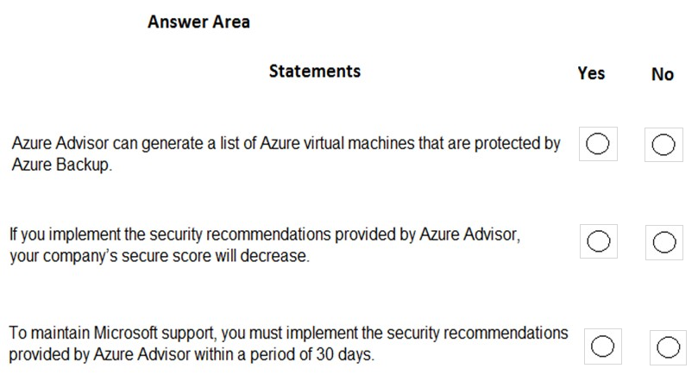

No, No, No

# Question #156

What can you use to automatically send an alert if an administrator stops an Azure virtual machine?

* A. Azure Advisor
* B. Azure Service Health
* C. Azure Monitor
* D. Azure Network Watcher

C

# Question #157

DRAG DROP -  
Match the Azure services to the correct descriptions.  
Instructions: To answer, drag the appropriate Azure service from the column on the left to its description on the right. Each service may be used once, more than once, or not at all.  
NOTE: Each correct match is worth one point  
Select and Place:  
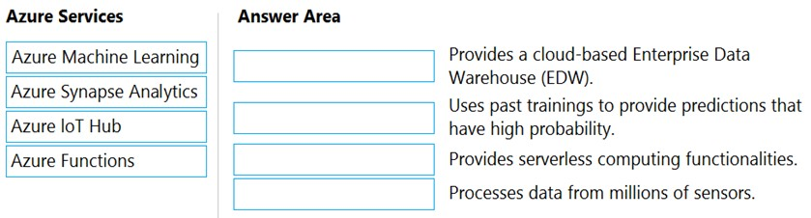

Azure Synapse Analytics, Azure Machine Learning, Azure Functions, Azure IoT Hub

# Question #158

You have an Azure environment.  
You need to create a new Azure virtual machine from a tablet that runs the Android operating system.  
What are three possible solutions? Each correct answer presents a complete solution.  
NOTE: Each correct selection is worth one point.

* A. Use Bash in Azure Cloud Shell.
* B. Use PowerShell in Azure Cloud Shell.
* C. Use the PowerApps portal.
* D. Use the Security & Compliance admin center.
* E. Use the Azure portal.

A, B, E

# Question #159

A team of developers at your company plans to deploy, and then remove, 50 virtual machines each week. All the virtual machines are configured by using Azure Resource Manager templates.  
You need to recommend which Azure service will minimize the administrative effort required to deploy and remove the virtual machines.  
What should you recommend?

* A. Azure Reserved Virtual Machine (VM) Instances
* B. Azure DevTest Labs
* C. Azure virtual machine scale sets
* D. Azure Virtual Desktop

B

# Question #160

HOTSPOT -  
For each of the following statements, select Yes if the statement is true. Otherwise, select No.  
NOTE: Each correct selection is worth one point.  
Hot Area:  
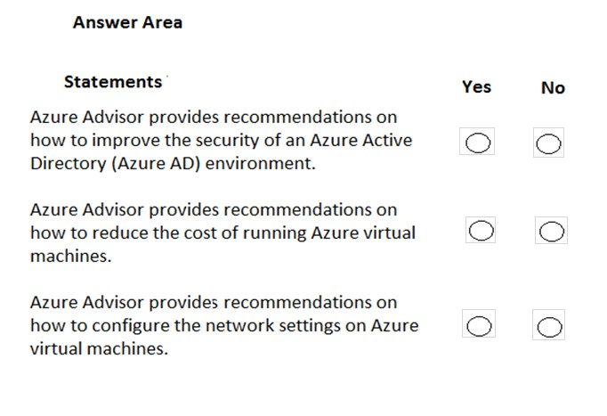

No, Yes, No

# Question #161

Note: This question is part of a series of questions that present the same scenario. Each question in the series contains a unique solution that might meet the stated goals. Some question sets might have more than one correct solution, while others might not have a correct solution.  
After you answer a question in this section, you will NOT be able to return to it. As a result, these questions will not appear in the review screen.  
You have an Azure subscription named Subscription1. You sign in to the Azure portal and create a resource group named RG1.  
From Azure documentation, you have the following command that creates a virtual machine named VM1. az vm create --resource-group RG1 --name VM1 --image UbuntuLTS --generate-ssh-keys  
You need to create VM1 in Subscription1 by using the command.  
Solution: From the Azure portal, launch Azure Cloud Shell and select PowerShell. Run the command in Cloud Shell.  
Does this meet the goal?

* A. Yes
* B. No

A

# Question #162

Note: This question is part of a series of questions that present the same scenario. Each question in the series contains a unique solution that might meet the stated goals. Some question sets might have more than one correct solution, while others might not have a correct solution.  
After you answer a question in this section, you will NOT be able to return to it. As a result, these questions will not appear in the review screen.  
You have an Azure subscription named Subscription1. You sign in to the Azure portal and create a resource group named RG1.  
From Azure documentation, you have the following command that creates a virtual machine named VM1. az vm create --resource-group RG1 --name VM1 --image UbuntuLTS  
--generate-ssh-keys  
You need to create VM1 in Subscription1 by using the command.  
Solution: From a computer that runs Windows 10, install Azure CLI. From PowerShell, sign in to Azure and then run the command.  
Does this meet the goal?

* A. Yes
* B. No

A

# Question #163

Note: This question is part of a series of questions that present the same scenario. Each question in the series contains a unique solution that might meet the stated goals. Some question sets might have more than one correct solution, while others might not have a correct solution.  
After you answer a question in this section, you will NOT be able to return to it. As a result, these questions will not appear in the review screen.  
You have an Azure subscription named Subscription1. You sign in to the Azure portal and create a resource group named RG1.  
From Azure documentation, you have the following command that creates a virtual machine named VM1. az vm create --resource-group RG1 --name VM1 --image UbuntuLTS  
--generate-ssh-keys  
You need to create VM1 in Subscription1 by using the command.  
Solution: From a computer that runs Windows 10, install Azure CLI. From a command prompt, sign in to Azure and then run the command.  
Does this meet the goal?

* A. Yes
* B. No

A

# Question #164

HOTSPOT -  
Several support engineers plan to manage Azure by using the computers shown in the following table:  
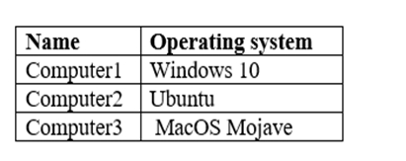  
You need to identify which Azure management tools can be used from each computer.  
What should you identify for each computer? To answer, select the appropriate options in the answer area.  
NOTE: Each correct selection is worth one point.  
Hot Area:  
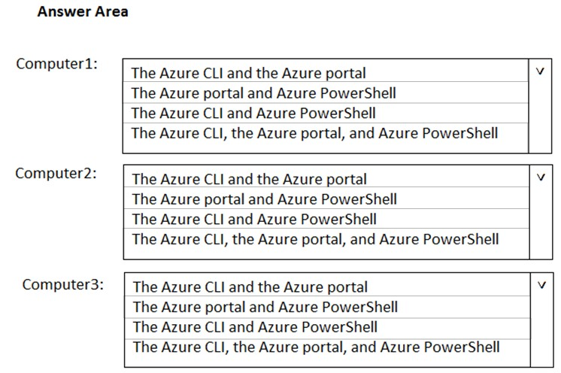

The Azure CLI, the Azure portal, and Azure PowerShell

The Azure CLI, the Azure portal, and Azure PowerShell

The Azure CLI, the Azure portal, and Azure PowerShell

# Question #165

HOTSPOT -  
To complete the sentence, select the appropriate option in the answer area.  
Hot Area:  
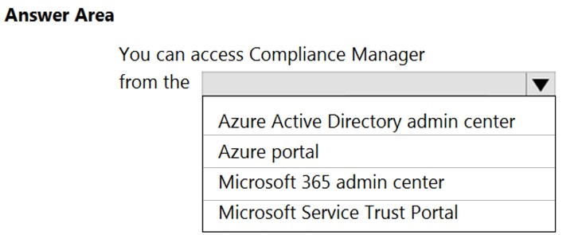

Azure portal

# Question #166

HOTSPOT -  
To complete the sentence, select the appropriate option in the answer area.  
Hot Area:  
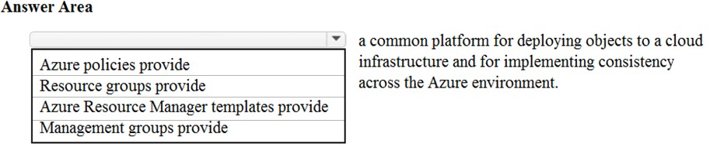

Azure Resource Manager templates provide

# Question #167

DRAG DROP -  
Match the Azure service to the correct description.  
Instructions: To answer, drag the appropriate Azure service from the column on the left to its description on the right. Each service may be used once, more than once, or not at all.  
NOTE: Each correct selection is worth one point.  
Select and Place:  
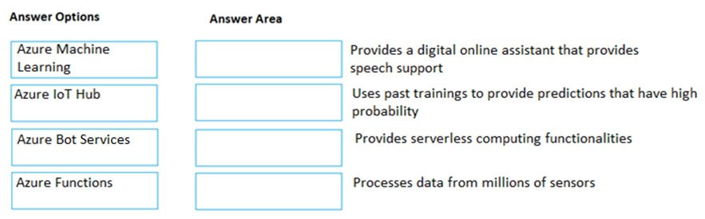

Azure Bot Services, Azure Machine Learning, Azure Functions, Azure IoT Hub

# Question #168

Note: This question is part of a series of questions that present the same scenario. Each question in the series contains a unique solution that might meet the stated goals. Some question sets might have more than one correct solution, while others might not have a correct solution.  
After you answer a question in this section, you will NOT be able to return to it. As a result, these questions will not appear in the review screen.  
An Azure administrator plans to run a PowerShell script that creates Azure resources.  
You need to recommend which computer configuration to use to run the script.  
Solution: Run the script from a computer that runs Windows 10 and has the Azure PowerShell module installed.  
Does this meet the goal?

* A. Yes
* B. No

A

# Question #169

DRAG DROP -  
Match the Azure services to the correct description.  
Instructions: To answer, drag the appropriate Azure service from the column on the left to its description on the right. Each service may be used once, more than once, or not at all.  
NOTE: Each correct selection is worth one point.  
Select and Place:  
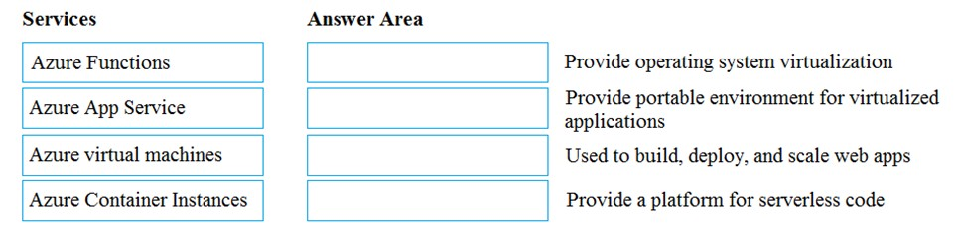

Azure virtual machines, Azure Container Instances, Azure App Service, Azure Functions

# Question #170

Which service provides serverless computing in Azure?

* A. Azure Virtual Machines
* B. Azure Functions
* C. Azure storage account
* D. Azure dedicated hosts

B

# Question #171

a) We can create policy group using Azure AD ---- Yes/No ---- Ans: No

b) We can join android devices to Azure AD -- Yes/No ---- Ans :Yes

c) We can join windows devices to AD ---------Yes/NO ---- Ans: Yes

a) Pay-as-you-go model is CapEx --- Yes/No ---- Ans: No

b) Reserved VM is OpeEx --- Yes/No ---- Ans: No

# Question #172

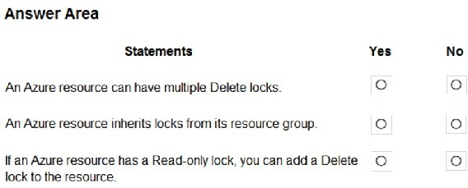

Yes, Yes, Yes

# Question #173

您有一个 Azure 环境，其中包含 10 个虚拟网络和 100 个虚拟机。您将限制所有 Azure 虚拟网络的入站流量。您应该创建什么？

1. 一个应用程序安全组 （ASG）
2. 10 个虚拟网络网关
3. 10 个 Azure 快速线路电路
4. 一个 Azure 防火墙

D

# Question #174

这个问题要求您评估带下划线的文本，以确定其是否正确。

您拥有由 Azure Web 应用程序组成的应用程序，该应用程序具有99.95% 和具有 99.99% 的 SLA 的 Azure SQL 数据库。应用程序的复合 SLA 是两个 SLA 的的产物，等于 99.94%。

说明：查看带下划线的文本。如果该语句正确，请选择"不需要更改"。如果该语句不正确，请选择使语句正确的答案选项。

1. 无需更改
2. 与应用程序关联的最低 SLA，即 99.95%
3. 与应用程序关联的最高 SLA，即 99.99%
4. 两个 SLA 之间的差值，即 0.05%

A

# Question #174

授权是验证用户凭据的过程。

说明：查看带下划线的文本。如果该语句正确，请选择"不需要更改"。如果该语句不正确，请选择使语句正确的答案选项。

1. 无需更改
2. 认证
3. 联合会
4. 票务

B

# Question #175

您需要配置满足以下要求的 Azure 解决方案：

* 保护网站从 m攻击
* 生成包含未遂攻击详细信息的报告

解决方案中应包含哪些内容？

1. Azure 防火墙
2. 网络安全组（NSG）
3. Azure 信息保护
4. DDoS保护

D

# Question #176

热点

您计划为 Azure 环境实现多个安全服务。您需要确定哪些 Azure 服务必须用于满足以下秒的尿点要求：

* 使用传感器监控威胁
* 基于条件强制实施 Azure 多重身份验证 （MFA）

应为每个需求标识哪个 Azure 服务？要回答，请在应答区域中选择相应的选项。

注：每个正确的选择都值一分。

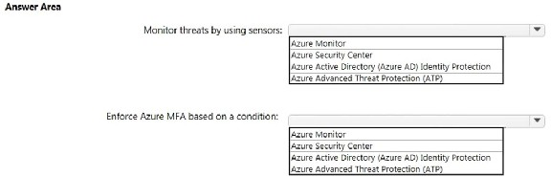

Azure Advanced Threat Protection (ATP), Azure Active Directory (Azure AD) Identity Protection.

# Question #177

公司计划将所有本地数据迁移到 Azure。您需要确定 Azure 是否符合公司的区域要求。您应该使用什么？

1. 知识中心
2. Azure 应用商店
3. Azure门户
4. 信托中心 Microsoft Service Trust Portal

D

部分：了解安全、隐私、合规和信任说明

解释/参考：

解释：

Azure 拥有 90 多个合规性认证，包括 50 多个特定于全球区域和（如美国、欧盟、德国、日本、英国、印度和中国）的认证。

您可以在信任中心查看合规性认证列表，以确定 Azure 是否符合区域要求。

引用：

https://azure.microsoft.com/en-gb/overview/trusted-cloud/compliance/

https://docs.microsoft.com/en-us/microsoft-365/compliance/get-started-with-service-trust-portal

# Question #178

这个问题要求您评估带下划线的文本，以确定其是否正确。

Azure 密钥保管库用于存储Azure 活动目录 （Azure AD） 用户帐户的机密。

说明：查看带下划线的文本。如果该语句正确，请选择"不需要更改"。如果该语句不正确，请选择使语句正确的答案选项。

1. 无需更改
2. Azure 活动目录 （Azure AD） 管理帐户
3. 个人身份信息 （PII）
4. 服务器应用程序

D

部分：了解安全、隐私、合规和信任说明

解释/参考：

解释：

在 Azure 密钥保管库中集中存储应用程序机密，可以控制其分发。密钥保管库大大减少了机密意外泄露的可能性。使用密钥保管库时，应用程序开发人员不再需要将安全信息存储在其应用程序中。不必在应用程序中存储安全信息，因此无需将此信息作为代码的一部分。例如，应用程序可能需要连接到数据库。您可以将连接字符串安全地存储在键盘保管库中，而不是将其存储在应用的代码中。

引用：

https://docs.microsoft.com/en-us/azure/key-vault/key-vault-overview

https://docs.microsoft.com/en-us/learn/modules/manage-secrets-with-azure-key-vault/

# Question #179

热点

对于以下每个语句，如果该语句为 true，请选择"是"。否则，请选择"否"。

注：每个正确的选择都值一分。

热门区域：

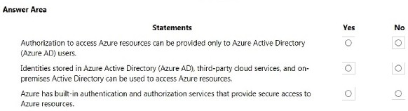

No, Yes, Yes

# Question #180

公司计划自动将服务器部署到 Azure。您的经理担心在部署期间可能会公开管理凭据。您需要推荐一个 Azure 解决方案，该解决方案在部署期间加密管理凭据。建议中应包括哪些内容？

1. Azure 钥匙保管库
2. Azure 信息保护
3. Azure 安全中心
4. Azure 多重身份验证 （MFA）

A

# Question #181

您计划部署多个 Azure 虚拟机。您需要控制 Internet 上的设备可用于访问虚拟机的端口。您应该使用什么？

1. 网络安全组（NSG）
2. Azure 活动目录 （Azure AD）角色
3. Azure 活动目录组
4. Azure 密钥保管库

A

# Question #182

这个问题要求您评估带下划线的文本，以确定其是否正确。

如果名为 RG1 的资源组具有 delete 锁，则只有全局管理员组的成员才能删除 RG1。

说明：查看带下划线的文本。如果该语句正确，请选择"不需要更改"。如果该语句不正确，请选择使语句正确的答案选项。

1. 无需更改
2. 删除锁必须在管理员之前删除
3. 必须在管理员之前修改 Azure策略
4. 必须在管理员之前添加 Azure标记

B

# Question #183

这个问题要求您评估带下划线的文本，以确定其是否正确。

Azure 德国仅可以由德国合法居民使用。

说明：查看带下划线的文本。如果该语句正确，请选择"不需要更改"。如果该语句不正确，请选择使语句正确的答案选项。

1. 无需更改
2. 只有在德国注册的企业
3. 只有企业从德国的合作伙伴那里购买其 Azure许可证
4. 任何用户或企业，需要其数据驻留在德国

D

# Question #184

这个问题要求您评估带下划线的文本，以确定其是否正确。

创建虚拟机后，需要修改网络安全组（NSG） 以允许连接到虚拟机上的 TCP 端口 8080。

说明：查看带下划线的文本。如果该语句正确，请选择"不需要更改"。如果该语句不正确，请选择使语句正确的答案选项。

1. 无需更改
2. 虚拟网络网关
3. 虚拟网络
4. 工艺路线表

A

# Question #185

注意：这个问题是一系列问题的一部分，这些问题呈现相同的场景。本系列的每个问题都包含一个可能满足既定目标的唯一解决方案。某些问题集可能有多个正确的解决方案，而其他问题集可能没有正确的解决方案。回答本节中的问题后，您将无法返回它。因此，这些问题不会显示在审阅屏幕中。

Azure 环境包含多个 Azure 虚拟机。您需要确保通过 HTTP 从 Internet 访问名为 VM1 的虚拟机。解决方案：修改网络安全组 （NSG）。

这符合目标吗？

1. 是的
2. 不

A

# Question #186

热点

对于以下每个语句，如果该语句为 true，请选择"是"。否则，请选择"否"。

注：每个正确的选择都值一分。

热门区域：

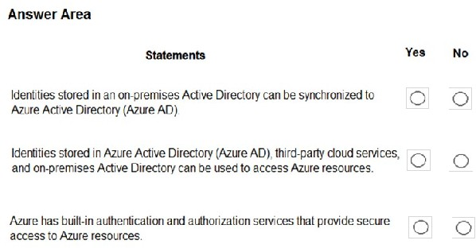

Yes, Yes, Yes

# Question #187

热点

对于以下每个语句，如果该语句为 true，请选择"是"。否则，请选择"否"。

注：每个正确的选择都值一分。

热门区域：

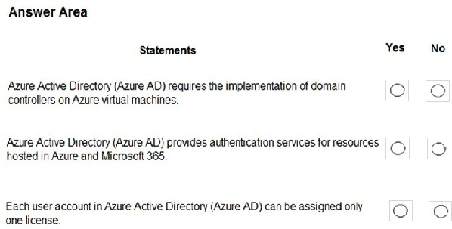

No, Yes, No

# Question #188

注意：这个问题是一系列问题的一部分，这些问题呈现相同的场景。本系列的每个问题都包含一个可能满足既定目标的唯一解决方案。某些问题集可能有多个正确的解决方案，而其他问题集可能没有正确的解决方案。

回答本节中的问题后，您将无法返回它。作为 result，这些问题不会显示在审阅屏幕中。

Azure 环境包含多个 Azure 虚拟机。您需要确保通过 HTTP 从 Internet 访问名为 VM1 的虚拟机。解决方案：您可以根据需要修改 DDoS保护。这符合目标吗？

1. 是的
2. 不

B

# Question #189

注意：这个问题是一系列问题的一部分，这些问题呈现相同的场景。本系列中的 Eac h 问题包含一个可能满足既定目标的独特解决方案。某些问题集可能有多个正确的解决方案，而其他问题集可能没有正确的解决方案。

回答本节中的问题后，您将无法返回它。因此，这些问题不会显示在审阅屏幕中。

Azure 环境包含多个 Azure 虚拟机。您需要确保通过 HTTP 从 Internet 访问名为 VM1 的虚拟机。解决方案：修改 Azure 防火墙。这符合目标吗？

1. 是的
2. 不

A

# Question #190

注意：这个问题是一系列任务离子的一部分，这些任务离子呈现相同的场景。本系列的每个问题都包含一个可能满足既定目标的唯一解决方案。某些问题集可能有多个正确的解决方案，而其他问题集可能没有正确的解决方案。

回答本节中的问题后，您将无法返回它。因此，这些问题不会显示在审阅屏幕中。

Azure 环境包含多个 Azure 虚拟机。您需要确保通过 HTTP 从 Internet 上可访问名为 VM1 的虚拟机。解决方案：修改 Azure 流量管理器配置文件。这符合目标吗？

1. 是的
2. 不

B

# Question #191

热点

对于以下每个语句，如果该语句为 true，请选择"是"。否则，请选择"否"。

注：每个正确的选择都值一分。

热门区域：

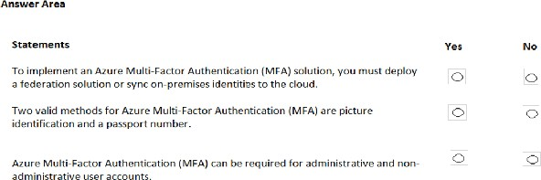

No, No, Yes

# Question #192

拖放将术语与正确的定义匹配。

说明：要回答，请将相应的术语从左侧的 column 拖动到右侧的说明。每个术语可以使用一次，不止一次，或者不能使用。

注：每个正确的匹配值一分。

选择并放置：

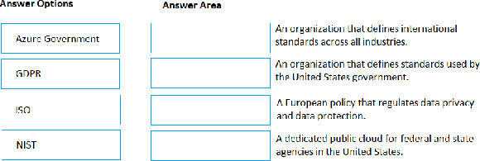

ISO, NIST, GDPR, Azure Government

# Question #193

应用程序应连接到什么来检索安全令牌？

1. Azure 存储帐户
2. Azure 活动目录（Azure AD）
3. 证书存储
4. Azure 密钥保管库

B

# Question #194

热点

对于以下每个语句，如果该语句为 true，请选择"是"。否则，请选择"否"。

注：每个正确的选择都值一分。

热门区域：

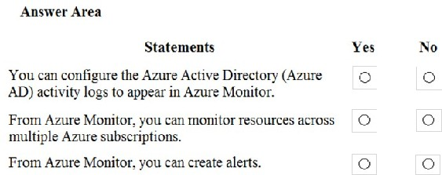

Yes, No, Yes

# Question #195

这个问题要求您评估带下划线的文本，以确定其是否正确。

从访问控制 （IAM），您可以查看哪些用户在过去 14 天内关闭了特定虚拟机。

说明：查看带下划线的文本。如果该语句正确，请选择"不需要更改"。如果语句不正确，请选择答案选项 that 使语句正确。

1. 无需更改
2. Azure 事件中心
3. Azure 活动日志 Azure Activity log
4. Azure 服务运行状况

C

# Question #196

Which 服务跨多个 Azure 订阅和虚拟网络提供网络流量筛选？

1. Azure 防火墙
2. 应用程序安全组
3. Azure DDoS保护
4. 网络安全组（NSG）

A

# Question #197

热点

在 Azure 资源管理器中创建名为 RG1 的资源组。您需要防止意外删除 RG1 中的资源。

您应该使用哪种设置？要回答，请在应答区域中选择适当的设置。

热门区域：

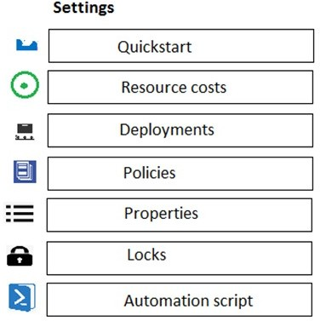

Locks

# Question #198

应使用哪种 Azure 服务来存储证书？

1. Azure 安全中心
2. Azure 存储帐户
3. Azure 密钥保管库 Azure Key Vault
4. Azure 信息保护

C

# Question #199

您有一个名为 RG1 的资源组。您计划在 RG1 中创建虚拟网络和服务。您需要防止仅在 RG1 中创建虚拟机。您应该使用什么？

1. 到lock
2. Azure 角色
3. 标记
4. Azure策略

D

# Question #200

Azure 信息保护可以加密什么？

1. 网络流量
2. 文档和电子邮件
3. Azure 存储帐户
4. Azure SQL数据库

B

# Question #201

应使用什么来评估公司的 Azure 环境是否符合法规要求？

1. 知识中心网站
2. Azure 门户中的"顾问"边栏选项卡
3. 来自安全信任门户的合规性管理器
4. Azure 门户中的安全中心边栏选项卡

D

# Question #202

这个问题要求您评估带下划线的文本，以确定其是否正确。

您的公司将更新Azure 策略，自动向包含信用卡信息的 Microsoft Word 文档添加水印。

说明：查看带下划线的文本。如果该语句正确，请选择"不需要更改"。如果该语句不正确，请选择使语句正确的答案选项。

1. 无需更改。
2. DDoS保护
3. Azure 信息保护
4. Azure 活动目录 （Azure AD） 标识保护

C

# Question #203

这个问题要求您评估带下划线的文本，以确定其是否正确。

在名为 RG1 的资源组中，有一个名为 VNET1的 Azure 虚拟网络。分配 Azure 策略，指定虚拟网络不是 RG1 中允许的资源类型。VNET1 is 将自动删除。

说明：查看带下划线的文本。如果该语句正确，请选择"不需要更改"。如果该语句不正确，请选择使语句正确的答案选项。

1. 无需更改
2. 自动移动到另一个 resource 组
3. 继续正常工作
4. 现在是只读对象

C

# Question #204

热点

对于以下每个语句，如果 statement 为 true，请选择"是"。否则，请选择"否"。

注：每个正确的选择都值一分。

热门区域：

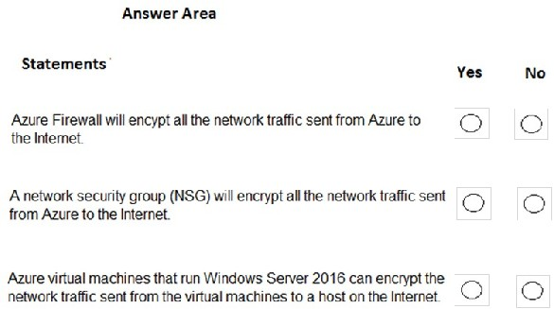

No, No, No

# Question #205

公司有一个 Azure 环境，该环境包含多个区域中的资源。

公司策略规定，必须只允许管理 或 在办公室所在地/地区创建其他 Azure 资源。

您需要创建必须满足策略要求的 Azure 资源。您应该创建什么？

1. 只读锁
2. Azure 政策
3. 管理组
4. 预订

B

# Question #206

这个问题要求您评估带下划线的文本，以确定其是否正确。

从Azure 云外壳，您可以跟踪公司的监管标准和法规，如 ISO 27001。

说明：查看带下划线的文本。如果该语句正确，请选择"不需要更改"。如果该语句不正确，请选择使语句正确的答案选项。

1. 无需更改。
2. 微软云合作伙伴门户
3. 合规经理 compliance manager
4. 信托中心

C

# Question #207

热点

对于以下语句的 each，如果该语句为 true，请选择"是"。否则，请选择"否"。

注：每个正确的选择都值一分。

热门区域：

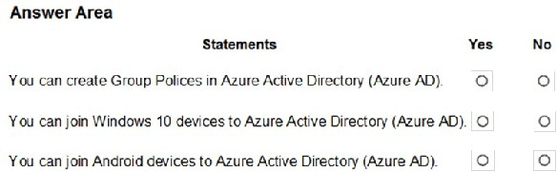

Yes, Yes, Yes

# Question #208

这个问题要求您评估带下划线的文本，以确定其是否正确。

Microsoft 在线服务隐私声明解释了 Microsoft 处理的数据、Microsoft 如何处理数据以及处理数据的目的。

说明：查看带下划线的文本。如果该语句正确，请选择"不需要更改"。如果该语句不正确，请选择使语句正确的答案选项。

1. 无需更改。
2. 微软在线服务条款
3. 微软在线服务级别协议
4. 微软 Azure 的在线订阅协议

A

# Question #209

热点

对于以下每个语句，如果该语句为 true，请选择"是"。否则，请选择"否"。

注：每个正确的选择都值一分。

热门区域：

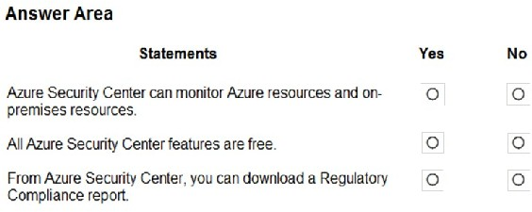

Yes, No, Yes

# Question #210

热点

对于以下每个语句，如果该语句为 true，请选择"是"。否则，请选择"否"。

注：每个正确的选择都值一分。

热门区域：

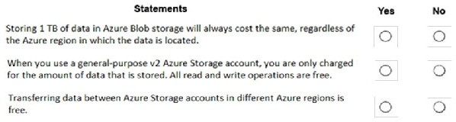

No, No, No

# Question #211

热点

对于以下每个语句，如果该语句为 true，请选择"是"。否则，请选择"否"。

注：每个正确的选择都值一分。

热门区域：

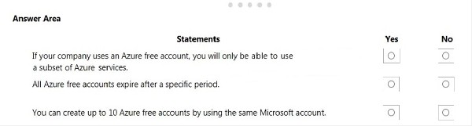

No, Yes, No

# Question #212

贵公司有10个办事处。您计划从 Azure 门户生成多个计费报告。每个报表将包含每个办公室的 Azure 资源利用率。

在生成报告之前，应使用哪个 Azure 资源管理器功能？

1. 标签 tag
2. 模板
3. 锁
4. 政策

A

# Question #213

热点

对于以下每个语句，如果该语句为 true，请选择"是"。否则，请选择"否"。

注：每次正确的选举都值一分。

热门区域：

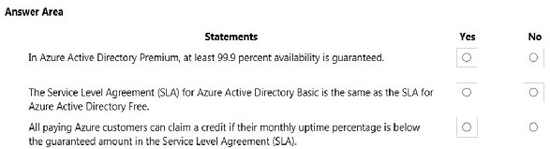

Yes, No, Yes

# Question #214

这个问题要求您评估带下划线的文本，以确定其是否正确。

部署 Azure 资源。由于服务中断，资源在较长段时间内不可用。微软将自动退还您的银行帐户。

说明：查看带下划线的文本。如果它使语句 correct，请选择"不需要更改"。如果该语句不正确，请选择使语句正确的答案选项。

1. 无需更改。
2. 自动将资源迁移到其他订阅
3. 自动贷记您的帐户
4. 向您发送优惠券代码，您可以兑换 Azure积分

C

# Question #215

热点

对于以下每个语句，如果该语句为 true，请选择"是"。否则，请选择"否"。

注：每个正确的选择都值一分。

热门区域：

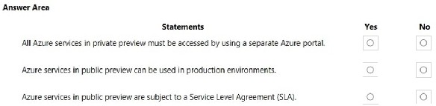

No, Yes, No

# Question #216

热点

对于以下每个语句，如果 statement 为 true，请选择"是"。否则，请选择"否"。

注：每个正确的选择都值一分。

热门区域：

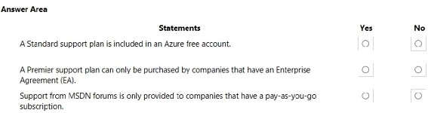

No, Yes, No

# Question #217

这个问题需要你评估带下划线的文本，以确定它是否正确。

如果 Microsoft 计划终止对没有后续服务的 Azure 服务的支持，Microsoft 将在至少12 个月前提供通知。

说明：查看带下划线的文本。如果该语句正确，请选择"不需要更改"。如果该语句不正确，请选择使语句正确的答案选项。

1. 无需更改。
2. 6 个月
3. 90天
4. 30天

A

# Question #218

热点

对于以下每个语句，如果该语句为 true，请选择"是"。否则，请选择"否"。

注：每个正确的选择都值一分。

热门区域：

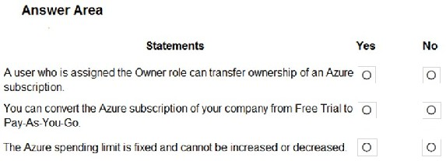

No, Yes, Yes

解释/参考：

解释：

方框 1：否

您需要是具有订阅的计费帐户的管理员才能转移订阅。这可能是计费管理员或全局管理员。订阅所有者可以管理订阅中的所有资源和权限，但不能转移订阅的所有权。

方框 2： 是

您可以将免费试用订阅转换为即用即付。对于希望在免费试用期到期时继续使用 Azure 服务的人，这是常见做法。

方框 3： 是

您可以取消支出限制，但无法增加或取消支出限制。

Azure 中的支出限制可防止支出超过信用额度。默认情况下，所有注册 Azure 免费帐户或订阅类型（包含多个月份信用额度）的新客户都启用了支出限制。支出限额等于信用额度，不能更改。例如，如果您注册了 Azure 免费帐户，则支出限制为 200 美元，并且无法更改为 500 美元。但是，您可以删除支出限制。所以，你要么没有限制，要么你的限额等于信用额度。

# Question #219

注意：这个问题是一系列问题的一部分，这些问题呈现相同的场景。本系列的每个问题都包含一个可能满足既定目标的唯一解决方案。某些问题集可能有多个正确的解决方案，而其他问题集可能没有正确的解决方案。

回答本节中的问题后，您将无法返回它。因此，这些问题不会显示在审阅屏幕中。

公司有一个 Azure 订阅，其中包含以下未使用的重新源：

* Azure 活动目录 （Azure AD） 中的 20 个用户帐户
* Azure AD 中的 5 个组
* 10 个公共 IP 地址
* 10 个网络接口

您需要降低公司的 Azure 成本。解决方案：删除未使用的网络接口。这符合目标吗？

1. 是的
2. 不

B

# Question #220

注意：这个问题是一系列问题的一部分，这些问题呈现相同的场景。本系列的每个问题都包含一个可能满足既定目标的唯一解决方案。某些 question 集可能有多个正确的解决方案，而其他组可能没有正确的解决方案。

回答本节中的问题后，您将无法返回它。因此，这些问题不会显示在审阅屏幕中。

Y 我们公司有一个 Azure 订阅，其中包含以下未使用的资源：

* Azure 活动目录 （Azure AD） 中的 20 个用户帐户
* Azure AD 中的 5 个组
* 10 个公共 IP 地址
* 10 个网络接口

您需要降低公司的 Azure 成本。解决方案：删除未使用的公共 IP 地址。这符合目标吗？

1. 是的
2. 不

A

# Question #221

注意：这个问题是一系列问题的一部分，这些问题呈现相同的场景。该系列的每个que stion 都包含一个可能满足既定目标的唯一解决方案。某些问题集可能有多个正确的解决方案，而其他问题集可能没有正确的解决方案。

回答本节中的问题后，您将无法返回该部分。因此，这些问题不会显示在审阅屏幕中。

公司具有包含以下未使用资源的 Azure 订阅：

* Azure 活动目录 （Azure AD） 中的 20 个用户帐户
* Azure AD 中的 5 个组
* 10 个公共 IP 地址
* 10 个网络接口

您需要降低公司的 Azure 成本。

解决方案：删除未使用的用户帐户。这符合目标吗？

1. 是的
2. 不

B

# Question #222

热点

您应该如何计算每月正常运行时间百分比？要回答，请在应答区域中选择相应的选项。

注：每个正确的选择都值一分。

热门区域：

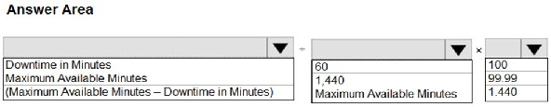

(Maximum Available Minutes – Downtime in Minutes), Maximum Available Minutes, 100

# Question #223

热点

对于以下每个语句，如果该语句为 true，请选择"是"。否则，请选择"否"。

注：每个正确的选择都值一分。

热门区域：

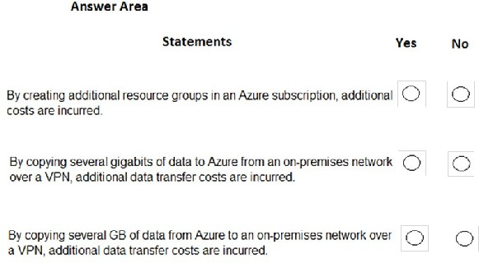

No, No, No

Data Transfer In free, Internet Egress First 100GB / Month free

# Question #224

这个问题要求您评估带下划线的文本，以确定其是否为 corr等。

A support plan solution that gives you best practice information, health status and notifications, and 24/7 access to billing information at the lowest possible cost is a Standard support plan.

说明：查看带下划线的文本。如果该语句正确，请选择"不需要更改"。如果该语句不正确，请选择使语句正确的答案选项。

1. 无需更改
2. 开发 人员
3. 基本 basic
4. 第一

C

# Question #225

这个问题要求您评估带下划线的文本，以确定其是否正确。

可以从 创建 Azure 支持请求support.microsoft.com。

说明：查看带下划线的文本。如果该语句正确，请选择"不需要更改"。如果该语句不正确，请选择使语句正确的答案选项。

1. 无需更改。
2. Azure门户
3. 知识中心
4. 安全和合规管理中心

B

# Question #226

注意：这个问题是一系列问题的一部分，这些问题呈现相同的场景。本系列的每个问题都包含一个可能满足既定目标的唯一解决方案。某些问题集可能有多个正确的解决方案，而其他问题集可能没有正确的解决方案。

回答本节中的问题后，您将无法返回它。因此，这些问题不会显示在审阅屏幕中。

公司具有包含以下未使用资源的 Azure 订阅：

* Azure 活动目录 （Azure AD） 中的 20 个用户帐户
* Azure AD 中的 5 个组
* 10 个公共 IP 地址
* 10 个网络接口

您需要降低公司的 Azure 成本。解决方案：删除未使用的组。

这符合目标吗？

1. 是的
2. 不

B

# Question #227

这个问题要求您评估带下划线的文本，以确定其是否正确。

Azure标准支持计划是通过电话接收支持工程师的 24x7 访问的最低成本选项。

分析：查看带下划线的文本。如果该语句正确，请选择"不需要更改"。如果该语句不正确，请选择使语句正确的答案选项。

1. 无需更改
2. 开发 人员
3. 基本
4. 专业直销

A

# Question #228

这个问题要求您评估带下划线的文本，以确定其是否正确。

All Azure services that are in public preview are provided without any documentation.

说明：查看带下划线的文本。如果该语句正确，请选择"不需要更改"。如果该语句不正确，请选择使语句正确的答案选项。

1. 无需更改
2. 只能从 Azure CLI配置
3. 从服务级别协议中排除
4. 只能从 Azure 端口al 配置

C

# Question #229

虚拟机的 Azure 服务级别协议 （SLA） 中保证什么？

1. 正常运行时间
2. 功能可用性
3. 带宽
4. 性能

A

# Question #230

这个问题要求您评估带下划线的文本，以确定其是否正确。

Azure 服务在公共预览版中时可供所有Azure 客户使用。

说明：查看带下划线的文本。如果该语句正确，请选择"不需要更改"。如果该语句不正确，请选择使语句正确的答案选项。

1. 无需更改。
2. 私人预览
3. 发展
4. 企业协议 （EA） 订阅

A

# Question #231

注意：这个问题是一系列问题的一部分，这些问题呈现相同的场景。本系列的每个问题都包含一个可能满足既定目标的唯一解决方案。某些问题集可能有多个正确的解决方案，而其他问题集可能没有正确的解决方案。

回答本节中的问题后，您将无法返回它。因此，这些问题不会显示在审阅屏幕中。

您的公司计划购买 Azure。

公司的支持策略规定，Azure 环境必须提供通过电话或电子邮件访问支持工程师的选项。

您需要建议哪个支持计划满足支持策略要求。解决方案：建议基本支持计划。

这符合目标吗？

1. 是的
2. 不

B

# Question #232

您的公司计划从 Microsoft 请求对 Azure 环境进行体系结构审查。公司目前有一个基本支持计划。

您需要为公司推荐一个新的支持计划。解决方案必须最大限度地降低成本。您应该推荐哪个支持计划？

1. 第一
2. 开发 人员
3. 专业直销
4. 标准

D

# Question #233

热点

对于以下每个语句，如果该语句为 true，请选择"是"。否则，请选择"否"。

注：每个正确的选择都值一分。

热门区域：

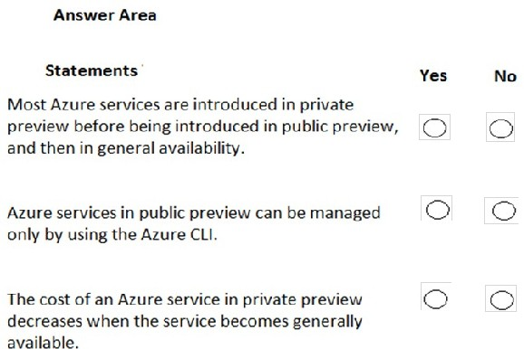

Yes, No, No

# Question #234

使用 Azure 成本管理需要什么？

1. a 开发/测试订阅
2. 软件保障
3. 企业协议 （EA）
4. "以时有付"订阅

C

# Question #235

这个问题要求您评估带下划线的文本，以确定其是否正确。

您的 Azure 试用帐户上周过期。您现在无法创建添加它自定义的 Azure 活动目录 （Azure AD） 用户帐户。

说明：查看带下划线的文本。如果该语句正确，请选择"不需要更改"。如果该语句不正确，请选择使语句正确的答案选项。

1. 无需更改
2. 启动现有的 Azure虚拟机
3. 访问存储在 Azure 中的数据
4. 访问 Azure门户

B

# Question #236

贵公司有10个部门。公司计划实现 Azure 环境。您需要确保每个部门可以对它使用的 Azure 服务使用不同的付款选项。您应该为每个部门创建什么？

1. 预订
2. 订阅
3. 资源组
4. 容器实例

B

# Question #237

热点

对于以下每个语句，如果该语句为 true，请选择"是"。否则，请选择"否"。

注：每个正确的选择都值一分。

热门区域：

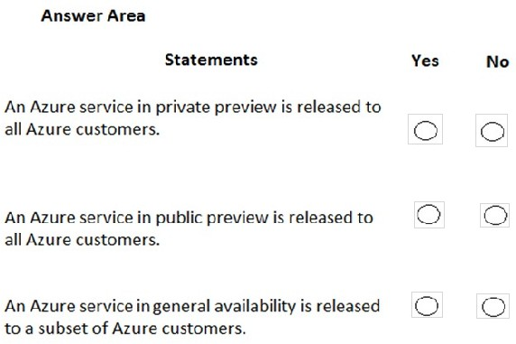

No, Yes, No

# Question #238

热点

对于以下每个语句，如果该语句为 true，请选择"是"。否则，请选择"否"。

注：每个正确的选择都值一分。

热门区域：

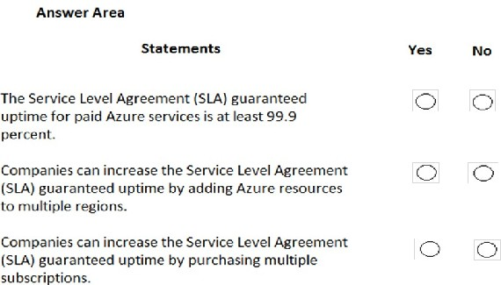

Yes, Yes, No

# Question #239

哪个语句准确地描述了 Azure 服务的现代生命周期策略？

1. 微软为一项服务提供为期五年的主流支持。
2. 在终止对服务的支持之前，Microsoft 至少会提前 12 个月发出通知。
3. 服务普遍提供后，Microsoft 至少为该服务提供支持四年。
4. 停用服务后，您可以购买长达五年的扩展服务支持。

B

# Question #240

这个问题要求您评估带下划线的文本，以确定其是否正确。

当 Azure订阅的当前计费周期成本超过指定限制时，可以使用 Azure 中的 Advisor 建议发送电子邮件。

说明：查看带下划线的文本。如果该语句正确，请选择"不需要更改"。如果语句不正确，请选择使语句正确的 answer 选项。

1. 无需更改。
2. 访问控制 （IAM）
3. 预算警报 cost alerts
4. 合 规

C

<https://docs.microsoft.com/en-us/azure/cost-management-billing/costs/cost-mgt-alerts-monitor-usage-spending>

# Question #241

热点

对于以下每个语句，如果该语句为 true，请选择"是"。否则，请选择"否"。

注：每个正确的选择都值得在e 点上。

热门区域：

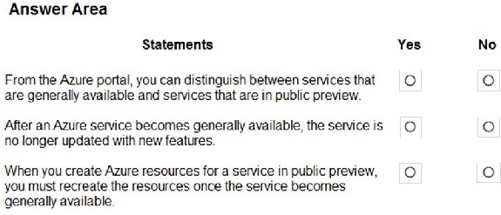

Yes, No, No

# Question #242

热点

对于以下每个语句，如果该语句为 true，请选择"是"。否则，请选择"否"。

注：每个正确的选择都值一分。

热门区域：

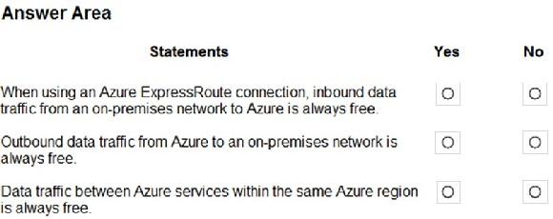

Yes, No, Yes

ExpressRoute inbound free, outbound based on plan, can be unlimited or charge

Other inbound free, outbound 100G/month free, free within same region for azure services

https://azure.microsoft.com/en-us/pricing/details/expressroute/

https://azure.microsoft.com/en-us/pricing/details/bandwidth/